

**An AI-Powered Car Towing Management System using Automatic Number Plate Recognition**

**Sheikh Tareq Ahmed**

A Project

Submitted to the Department of Computer Science

In Partial Fulfillment of the Requirements for

The Degree of

MASTER OF SCIENCE

IN

COMPUTER SCIENCE

PRAIRIE VIEW A&M UNIVERSITY

ROY G. PERRY COLLEGE OF ENGINEERING

PRAIRIE VIEW, TEXAS

Dec 2020

PRAIRIE VIEW A&M UNIVERSITY

COLLEGE OF ENGINEERING

PRAIRIE VIEW, TEXAS

**An AI-Powered Car Towing Management System using Automatic Number Plate Recognition**

A Project

Submitted to the Department of Computer Science

In Partial Fulfillment of the Requirements for

The Degree of

MASTER OF SCIENCE

IN

COMPUTER SCIENCE

Submitted By:

**Sheikh Tareq Ahmed**

Certificate of Approval:

____________________________

Ahmed Ahmed

Student Advisor

Assistant Professor

Department of Computer Science

____________________________

Lin Li

Graduate Program Coordinator

Associate Professor

Department of Computer Science

____________________________

Yonggao Yang

Professor and Department Head

Department of Computer Science

Dec 2020

**ABSTRACT**

**An AI-Powered Car Towing Management System using Automatic Number Plate Recognition**

Automatic Number Plate Recognition (ANPR) is a technology that can recognize vehicle number plates automatically using high-speed cameras. It involves detecting the position of the plat in the vehicle, identifying the characters and digits in the plat, and converting the captured image to text. There are many ANPR applications in different domains, such as car park management, traffic management, tolling, and intelligent transport systems. Despite this technology's importance, the existing ANPR approaches suffer from the accurate identification of number plats due to its different size, orientation, and shapes across different regions worldwide. In this project, we tried to study these challenges by implementing an empirical case study for smart car towing management using machine learning models. The developed mobile-based system uses different approaches and techniques to enhance the accuracy of recognizing number plates. First, we developed an algorithm to accurately detect the number plate's location on the car body. Then, the bounding box of the plat is extracted and converted into a grayscale image. Second, we applied a series of filters to detect the alphanumeric characters' contours within the grayscale image. Third, the detected the alphanumeric characters' contours are fed into a K-Nearest Neighbors (KNN) model to detect the actual number plat. Our model achieves a classification accuracy of 95% in recognizing number plates across different regions worldwide. The user interface is developed as an Android mobile app, allowing law-enforcement personnel to capture a photo of the towed car, which is then recorded in the car towing management system automatically. The app also allows owners to search for their cars, check the case status, and pay fines. Finally, we evaluated our system using various performance metrics such as classification accuracy, processing time, etc.

**ACKNOWLEDGMENTS**

I am very pleased and honored that I have successfully completed this project. The idead has come to my mind when my car has been towed for parking in a unauthorized place. I am excited I finally finished my final project and present this for my master’s degree at the Department of Computer Science, College of Engineering Prairie View A&M University Texas. I,sincerely, very thankful to Allah for having the privilege of sound health and mind to start this project from the time of conceptualization to the final research submission and defense.

I sincerely appreciate Dr. Ahmed Ahmed, Assistant professor of Computer Science Department, who has been guiding me and supporting me from the beginning of this project as my Supervisor. Without his assistance, this project would not be a huge success. I really appreciate the efforts that he put into the development and completion of this project.

Moreover, I will thank all of my other professors and course teachers who have helped me to learn more and help me in various topics and with this project. Furthermore, I would want to specially thank my Program Coordinator and Academic Advisor Dr. Lin li for his assistant and availability whenever I knocked him for something. I would also like to thank Udemy where I have learned basic concept of machine learning and how to build a successful android application that were used in this project and other related works.

Finally, I would like to thank to my friends and family for their unending support and care during my study for my master’s degree. Without your support, it would have been very difficult for me to complete my master’s degree.

For each other individual that contributed in one manner or the other for this project, I sincerely wish to state an immense thanks to all of you.

# TABLE OF CONTENTS

Page

ABSTRACT………………………………………………………………………………..…... iii

ACKNOWLEDGMENTS………………………………………………………………….........iv

TABLE OF CONTENTS…………………………………………………………………….... v

LIST OF FIGURES…………………………………………………………………………….. ix

LIST OF TABLES..…………………………………………………………………………… xi

CHAPTER 1 INTRODUCTION………………..............….………………………………….. 1

CHAPTER 2PROJECT PLAN……………..……………………………………………......... 6

2.1 TASK IDENTIFICATION…………………………………………….………………... 6

2.2 PROJECT PROPOSAL………………..………………………………………………... 7

2.3 RESEARCH ……………………….……………………..……………………………... 8

2.4 REQUIREMENT SPECIFICATION……………………..…………………………….. 9

2.5 DESIGN………….……………………………………………………………….......... 10

2.6 CONSTRUCTION………………………..……………………………………............ 10

2.7 TESTING……………….……………………………………………………………… 11

2.8 DOCUMENTATION……………………………………………………..…............... 11

2.9 PROGRESS SCHEDULE (GANTT CHART)…………………………….................. 12

CHAPTER 3 PROJECT SCOPE………….………………………..…………..………........... 14

3.1 PROBLEM STATEMENT…………………….……………………...……....………. 14

3.2 SCOPE………………………………………….……………………...……...………. 15

3.3 PROJECT OBJECTIVES AND GOALS……..……………………...……….……… 15

CHAPTER 4 LITERATURE REVIEW…………...………….…………..………………….. 17

4.1. BACKGROUND………………………………………………………...................... 17

4.2 GUN VIOLENCE…………………..…………………..…...……………………….. 18

4.3 CYBER-PHYSICAL SYSTEMS …...………………………………………...……... 19

4.4.1 EMBEDDED SYSTEMS …………………………………………………………... 20

4.5 MODELS ……………..……………………………………………………............... 20

4.5.1 CNN…………………………… …………………………………………….......... 20

4.5.1.1 CNN COMMON FEATURES ….…………………………………………......... 20

4.5.2 MASK R-CNN ……………………………….………………………………......... 23

4.5.2.1 MASK R-CNN COMMON FEATURES……..…………………………….......... 23

CHAPTER 5 DESIGN AND IMPLEMENTATION………….…………..……………......... 25

5.1. SYSTEM ARCHITECTURE…………………….……………………...................... 26

5.2 ANALYSIS AND DESIGN OF STRUCTURE 1……..…...………….……………... 28

5.3 ANALYSIS OF THE DESIGN OF STRUCTURE 2 ………………………………... 29

5.4 ANALYSIS AND IMPLEMENTATION OF THE GENERAL SYSTEM ...………... 30

5.4.1 HARDWARE FEATURES ……………………………………………….............. 30

5.4.2 SOFTWARE FEATURES ……………………………….………………………... 33

5.4.3 DATASET …………………………………………………………………............ 35

5.4.4 MODEL-SERVER DESIGN ………………….……………………..……............... 36

5.5 ANALYSIS OF THE MODELS …….…………...………………………….….......... 37

5.5.1 CNN MODEL/IR MODEL …..……………….….….………………….…….......... 37

5.5.2 MASKRCNN MODEL ……….……………….……..……………..…………......... 39

5.6 USER INTERFACE (GUI) ……..……………...……….………………………......... 43

5.7 CODE SNIPPET ………………..…………...……….…………………………....... 44

CHAPTER 6 EXPERIMENTAL EVALUATION……….………………………………….. 47

6.1 SOURCES OF DATA ………………………...………………………………............ 47

6.2 DATA VISUALIZATION ………………...…………………………………………. 48

6.3 DATA PRE-PROCESSING ……………………………………………………........... 49

6.3.1 DATA AUGMENTATION ………………………………………………………... 50

6.3.2 DATA ANNOTATION ……………………..……….………………………............ 50

6.3.3 DATASET PROCESSING AND STATISTICS …………………………………... 51

6.4 TRAINING DATA …………………………………………………………….......... 52

6.5 INTERMEDIATE REPRESENTATION (IR) MODEL ……………………………… 57

6.6 RESULT AND EVALUATION ……………….…………………...………….......... 58

6.6.1 TRAINING RESULT OF THE CNN MODEL ………………….....……………... 58

6.6.2 TESTING RESULT OF THE CNN MODEL.……….……………………….......... 59

6.6.3 TRAINING RESULT OF THE MASKRCNN MODEL ………...………………... 61

6.7 RESULT ANALYSIS …………………………………………………………............ 62

CHAPTER 7 CONCLUSION AND FUTURE WORK ………………………..…………..... 65

7.1 CONCLUSION ……………………………...……………………….………………. 65

7.2 FUTURE WORK ………………………………...……………….………................. 66

REFERENCES…………………………….……………..……….……………………… 67

APPENDIX …………………………………………………....…………………………. 70

# LIST OF FIGURES

Page

1. Project progress schedule ……………………………………………………….. …..............13

2. Gun violence report in the last decade……………………………………….……………... 19

3. CNN kernel performing feature extraction .………………………………………………… 23

4. System architecture for the models **.**………………………….…………………………….. 26

5. Embedded System architecture and the interactions among its component ………………... 27

6. Hardware components used on hawk-eye …………………..……………………………… 32

7. Peripheral devices **…………………………….……**……………………………………….. 33

8. Modeland Server design**……………………………**………………………………............. 35

9. Simple CNN Model………………….……………………………………........................... 38

10. Structure of the CNN model ………………………..………..…………………………… 38

11. A high-level description of Mask-RCNN Model …………………………………............. 39

12. Structure of the Mask-RCNN model …..………………………………………………….. 42

13. Home page of Hawk-eye ………………………………………………………………….. 43

14. Result of the inference on the CNN model..…………….…………………….…………… 44

15. Result of the inference on the CNN model…………………………………….................... 44

16. Loading of the data ……………………………………………………………................... 45

17. Data generator ……………………………………………………………….……………. 46

18. Data source .……………………………………………………………………………….. 47

19. Project Schedule…………**.**……………………….…………………….………..……….. 47

20. Project Timeline……..…………………………………………………………...………... 49

21. Rotated images to increase the dataset …………………..……………………….….......... 50

22. Annotated images **…………………….…………**………………………………….……... 51

23. Data statistics …………………..…….……………………………………......................... 52

24. Data statistics …………………..…….……………………………………......................... 52

25. Training Data statistics for CNN ………………………..………..……………………….. 53

26. Training Data statistics for Mask-RCNN …………………..……….……………….......... 54

27. CNN training code snippet …..…………………………...……………………………….. 55

28. MASKRCNN training code snippet ………………………………………………...…….. 56

29. Working of the IR model …………………....………………………………….……......... 57

30. Training accuracy and loss ………………………………………………………............... 58

31. Confusion matrix ………………………….……………………...……………………….. 59

32. Classification report…………………………….………………...………………………... 60

33. ROC Curve ………………………………………………………………….…………….. 60

34. Precision vs. Recall Curve ………………………………………………….……………... 61

35. Mask-RCNN loss vs. validation loss …..……………………...…………………………... 61

36. Predictions using the CNN model …………………………………………….…………... 63

37. Predictions using the Mask-RCNN model …..………………...…………………………... 64

# LIST OF TABLES

Page

1. User Functional Requirements ……………………………………………………………....7

2. Authority Functional Requirements …………… …………………………………………...8

3. Data statistics ……………………………………………………………………………..… 52

4. Training Data statistics for CNN .……………………………………………….………….. 53

5. Training Data statistics for Mask-RCNN …………………………….…………………….. 54

6. Result of the models ………………………………….………………………………..…… 62

**CHAPTER 1**

# INTRODUCTION

**Background:** This ear is the era of communication between everything: from software to software, software to hardware and also hardware to hardware. Now it is the time for Machine learning also. Combining the machine intelligence with communication and useability seems to become and interesting topics around. And all of these are not only making technology safer and bring the user closer but also cheaper. Detection of number plate in a car is always challenging the reasons behind is not much complex to understand. It is due to the varieties of numberplates found around the world. So, each of kind need separate module to detect it. So, a new algorithm that can replace this issue by a unified model can solve this problem. Moreover, combining this approach with a real-life use case can sever a novel purpose to the community. Towing is very common for our day to day life. For parking out car in wrong places. Due to this system being manual in nature it creates problems for the car owners. The car being towed, and the owner seems to know what had happened to his car until the car reached to the specific towing location. So, to remove this problem an app which combines the unified numberplate detection module with it can solve the issues and make the towing process smoother and customer friendly. This means that we are free from anxiety and tension if our car is towed. Moreover, we can use this app as one of the use cases of our Numberplate detection module as well.

**Components:**

1. **Hardware:** We are building an android app which can be able to take picture and communicate with the sever instantly. So, any smart phone which has an android version of 8.0 or higher can use this app.
2. **Software:** The software part of this project is the applications running on the mobile devices and also the ML module for detecting characters from license plates which is ruining in the server and these two things are the key component and the foundation of our project.

**Results:** For the app, we have the server which holds the ML module and the database. So, if we consider the module separately. It’s gives an average accuracy of 95% for any random sets of numberplates with an average execution time of around 10ms. But in the app the ML module execute more than our expected execution time due to the communication overhead of the server and our mobile devices.

**Conclusion:** Based on the experiments and results, our app is preforming like an industrial grade. Considering not because of how economical it is but how smarter the towing can become. The advantages and prospect of this project can’t be overlooked. Public schools, malls, companies, industries, private properties or even the entire parking/towing system can be put under the same umbrella or this app. Beside this, our ML module is very light weight. It requires less than 3Mb of memory. So, implementing this ML model on other used cases like parkin management, tolls on the highways will not be too expensive and complicated to develop as we can see the requirements.

In the next chapters, we will go more the result analysis of our models and the UI, Database and all the functionalities of our app. The various evaluations have been used to check this application which will be clearly explained in the coming chapters.

**Future Work:** The complete app with the Number plate detection module resembles great opportunities and potential for the future. There are many areas that are of great importance. A lot of sectors can be greatly improved on especially when it comes to UI , Machine learning and Server client communication. I will focus some of those in the near future:

* In the server client communication, there is a big overhead which downgraded the overall performance of the system. The solution is pretty simple, for detecting number plate we can use the device computation power to get the result locally. But our ML module has be developed with python. On the other hand, then android app is built by java. So, there is not an easy way to incorporate a python packages inside java. This is the most challenging task. So, in near future I will try to solve this issue the we will be able to get the accurate execution time of the project.
* We can also work on improving the UI and also can focus on user privacy and data security. We can also implement biometric authentication in the future that will make our app more secure and user friendly.
* Video streaming support of our ML module can one of the key point an important future work which I am working now. It will increase the flexibility of the models .

We will discuss about our development process of the app and our proposed algorithm and results:

* Chapter 2 we have listed all the project plan stages and the development works of each stage
* Chapter 3 reviews of the previous works in related field and how our proposal is different from their ideas.
* Chapter 4 discuss our models, developments, different frame works
* Chapter 5 Algorithm, methodology and results.
* Chapter 6 Discuss the use cases, class diagram, sequence diagrams, dataflow diagrams
* Chapter 6 discusses databases of the of the system.

**Keywords:** Machine learning, Android, KNN, Retrofit, Server, Data Privacy, Android studio.

**CHAPTER 2**

# PROJECT PLAN

* 1. Task Identification

Proper and precise Identification of the project tasks plays a very important role in the successful outcome of the project. The aim guarantees this overall successful and interesting outcomes. The main idea and task of this project is to build such machine learning module that can detect any kind of numberplate without an error and also developed an app to solve an existing problem in towing management via using the ML module in it. The current trends in the field of machine learning is not only confined to build a good model but also to apply this model to solve any existing issues. We have proposed and built a modified algorithm for detecting any number plates irrespective of their regions, sizes and colors. We have built our module which supports Unix and Linux both. The other idea that includes building a mobile app that can solve the existing manual towing system. For the ML module of detecting number plates our idea is to find the bounding rectangle of the numberplate from each of the pictures and thus truncate that rectangle and then pass the reduced image through an existing pretrained character recognition module can solve this problem. And applying this module in smart towing app can further help in detecting a numberplates can be an interesting use case. So, our focus of this project is to build an app which will not only make the existing towing system by giving the user real time scenario when their vehicle is towed but also will provide an interfaces that of the Number plate detection module which acts as an one of the functions of the app and make the towing process further easier and smoother. And furthermore, we can have a better idea of the behavior of our ML modules in a real-life scenario.

* 1. Project Proposal

The current methods of towing is mostly manually done by people/authority who their daily job requires watching and finding unauthorized parking and thus tow or fine the car without letting the owner knowing about their car has been towed or fined. If the car is fined most likely the authority will put a ticket on the windshield which most of the times the people don’t even noticed which further generates more fines. And for the towing procedure is even worse. The authority tow the car without notifying the owner which further creates confusion among the owner when they didn’t find their car where they had parked it. It becomes more horrifying when he called the authority and the authority failed to track the vehicle because it won’t be updated to their database until the towed vehicle does not reach their location. Plus inputting the number plates is manual which can also cause further error. To check the numberplate we can use our proposed ML module which can detect all kind of numberplate with a marginal error.

The Smart Towing app with number plate detection module for the vehicle was proposed to achieve mainly three goals:

1. To solve the existing manual towing system by making this process fully digital.
2. Provide an interface for the machine learning module for detecting numberplates.
3. To make a comparison between how The ML module work in real-life scenario(server-client) vs the local devices.

As mentioned before, this project will replace most of the traditional ways of towing system. Also, this project can be improved in the future which can be used to make a centralized towing system throughout the country.

* 1. **RESEARCH**

Over the last decades, Machine leaning seems to be a hot topic. Many researches have been done for detecting number plates by using machine learning but almost all of them are region specific and failed to detect the number plates from different regions.

The background studies and research started with comparison of different Machine leaning model for detecting number plates [44]. Here we can see a lot of comparison based of different approach to solve and recognizing characters from the plates. Here, before choosing any approach I have put one thing in my mind that is the ML module should be very small in size so that in can be fitted to a lot of domains. After studying some research papers one thing was pretty clear there is several kind of character recognition modules which performs pretty well in recognizing characters. The ideas that are adopted from this research is the main drawback of detecting a numberplates is not actually related to the character recognition but to detect the Min bounding rectangle around the license plate number. And for detecting different number plates we have different region-specific models and training data.

Based on my research, my idea is to divide this problem into two consecutive steps. One is to find the minimum bounding rectangle around the possible number plates. Thus, truncate that area and pass that area to any good character recognition module. For the character recognition module, we have to only deal with the Numerical characters (0-9) and Upper alphabets(A-Z) . And these characters are usually written in five fronts [44]. So, we have a very small domain of training set. And for any small training set KNN usually out preforms. That’s why we have taken a pretrained KNN Model which has an accuracy rate of 95-96%.

All the details of the choice of certain KNN models, structure, parameters and technologies will be thoroughly explained in the following chapters. The result and evaluation will also be explained with illustrative pictures.

* 1. Requirement Specification

The requirement on the specification needed for our project. For the app and the module we needs following requirements:

**Functional Requirements:**

Functional requirements define specific functionality that define what a system is supposed to accomplish. A function is described as a set of inputs, the behavior, and outputs. Requirement analysis is a software engineering technique that is composed of the various tasks that determine the needs or conditions that are to be met for a new or altered product, taking into consideration the possible conflicting requirements of the various users.

Functional requirements are those requirements that are used to illustrate the internal working nature of the system, the description of the system, and explanation of each subsystem. It consists of what task the system should perform, the processes involved, which data should the system holds and the interfaces with the user

Following are some functional requirements of our project:

**Table 1. User Functional Requirements:**

|  |  |  |  |
| --- | --- | --- | --- |
| **Requirement ID** | **Requirement Statement** | **Must/Should/Could/Would** | **Comments** |
| FR001 | User Signup | Must | User Signup support login Email |
| FR002 | Login | Must | No login using guest (user need to register compulsory) |
| FR003 | Reset Password/Forget Password | Must | User will reset his/her password |
| FR004 | Profile | Must | User can able to update/edit modify user details like mobile number, email, Calendar In profile |
| FR005 | Manage Cars | Should | Users can manage their cars to pay fines |
| FR006 | View Challans | Should | Users can view their challans |
| FR007 | Pay fines | Should | User will pay the challan fine from here |
| FR008 | Fines history | Should | User will check his/her previous fines |
| FR009 | Complaints | Should | User will complaint if they are facing any problem directly to the authorities |

**Table 2. Authority Functional Requirements**

|  |  |  |  |
| --- | --- | --- | --- |
| **Requirement ID** | **Requirement Statement** | **Must/Should/Could/Would** | **Comments** |
| AFR001 | Authority Signup | Must | Authority Signup support login Email |
| AFR002 | Login | Must | No login using guest (Authority need to register compulsory) |
| AFR003 | Reset Password/Forget Password | Must | Authority will reset his/her password |
| AFR004 | Profile | Must | Authority can able to update/edit modify Authority details like mobile number, email, Calendar In profile |
| AFR005 | Make a Fine | Should | Authority will add fines for the user who are violating laws |
| AFR006 | View History | Should | Authority can check their history regarding fines and challans made by them |

**Non-functional requirements**

Non-functional requirements, as the name suggests, are requirements that are not directly concerned with the specific services delivered by the system to its users. They may relate to emergent system properties such as reliability, response time, and store occupancy . Alternatively, they may define constraints on the system implementation such as the capabilities of I/O devices or the data representations used in interfaces with other systems. Non-functional requirements, such as performance, security, or availability, usually specify or constrain characteristics of the system as a whole. They are:

**Usability**

The system provides help and support menu in all interfaces for the user to interact with the system. The user can use the system by reading help and support.

**Security**

The system provides username and password to prevent the system from unauthorized access.

**Performance**

The system response time for every instruction conducted by the user must not exceed more than a minimum of 10 seconds.

* Ability to maintain huge amount of customers on the server at once without crashing
* Speedy performance / transmission of data
* Send any emails immediately
* Have a quick recovery time if anything were to go wrong
* Display accurately and efficiently on all devices (responsive view)

**Error handling**

Error should be considerably minimized and an appropriate error message that guides the user to recover from an error should be provided.

**Availability**

The system should always be available for access at 24 hours, 7 days a week.

**Ease of use**

The user interface should be developed to make it easy to understand and required less training.

**Quality Attributes:**

● Maintain a user-friendly environment that is visually appealing

● Easy to see and use navigation

● Maintain readable content

● Searching cars should be accessible to people who are and are not logged in

● Selecting and making a payment should be available to customers who are and are not logged in

**Security Requirements:**

● Secure any transmissions of private information between the customer and the

company

● Prevent any potential threats such as SQL injections through the forms or search boxes.

● Prevent third party users at administration level

● Verify website security certificates (that lock in the address bar)

● Prevent false information from being used as payment

● Prevent false email inputs from being used when registering

**Other Requirements:**

**Hardware Requirements**

* Device: Android Smartphone
* Memory Space: 32 GB of disk space, 4 GB of RAM for development machine
* Connector: USB cable to export the app from development machine to Android device.
* 1 GB for Android SDK, emulator system images and cache.

**Software Requirements**

* Eclipse JAVA IDE EE for web developers.
* Android studio
* Android SDK and AVD installed on development machine.
* Java (JDK) 1.6
* Android Plug-in
* MYSQL for database
* PyCharm
* NumPy 1.18.4
* Servers
  1. Design

A good user interface plays a very important role for a project to be successful both technically and financially. Thus, I have given much importance in developing a good GUI.

The app has several web pages which are very simple and easy to understand. The smart twing app provide login page for three kinds of user (User, authority, admin). Each of the user has their own dashboard and functionalities.

2.6 Construction

All the developments of this project were carried out on various platforms and IDEs at various stages of this project. I generally worked on both the Ubuntu 16.04 version and MacOS. For development of the ML module was mostly done in the ubuntu. And the Smart towing app were developed in the macOS. Python was used for developing the Number Plate detection module along with OpenCV. The app was developed in android studio using java. XML was used for the GUI.

2.7 Testing

Various kinds of testing were done in every stages of the development of the project. The first test that was carried out was technical testing and this was done to check the scripts and codes are performing properly. I am briefly discussing below about some of the testing that were also carried out:

### **UNIT TESTING:**

Unit testing bases check effort on the most diminutive unit of programming for instance the module. Using the low down arrangement and the strategy points of interest testing done to uncover bumbles inside the farthest point of the module. All modules must be viable in the unit test before the start of the joining testing begins. In this errand, every organization can be thought of a module. There are such a critical number of modules like Selection, Listing, Execution, and Import and Export. Giving unmistakable game plans of data sources has attempted each module. When developing the module similarly as finishing the progression so every module works with no screw up.

### **INTEGRATION TESTING:**

After the unit testing, we have to perform blend testing. The goal here is to check whether the module consolidated suitably. In this endeavor fusing all of the modules from the guideline system. I have checked whether the joining impacts working of any organizations by giving particular blends of commitment with which the two organization run brilliantly before compromise testing**.**

### **User input validation:**

The User input has to be approve to adjust to anticipated qualities. Different areas, for example, content info, need to limit the length of the characters that can entered. In the event that the Login id and secret key is less, than 6 characters the mistake message will be shown and the fields ought to likewise not be vacant.

### **VALIDATION:**

The structure and execution of 'Space Radiation Data Analyzer' is finished by utilizing Java, Android SDK as front-end which involves XML and MySQL as backend for putting away and recovering information which contains PHP this makes the application responsive. The simple to utilize interface empowers quicker and less unpredictability for the clients. This application causes the client to know how the space responds or by breaking down the particles, we would most likely figure out what may occur in not so distant future.

2.8 Documentation

The documentation is a very important part of a project which can’t be neglected also. If you can’t present your project with proper documentation, people won’t appreciate your work.The documentation started from planning and constructing the ideas behind this project,understanding the problems and a detailed method or procedure to find a tangible solution that is unique and has greater novelty of solving the problem.

This report pretty much explains the aims and objectives, methodology, technologies, design, results, etc. of this project. This further illustrates the reasons being using each of the technologies along with the approaches.

2.9 Progress Schedule (GanTt Chart)

**Project scheduling** is a mechanism to communicate what tasks need to get done and which organizational resources will be allocated to complete those tasks in what timeframe. ... A **project** is made up of many tasks, and each task is given a start and end (or due date), so it can be completed on time.

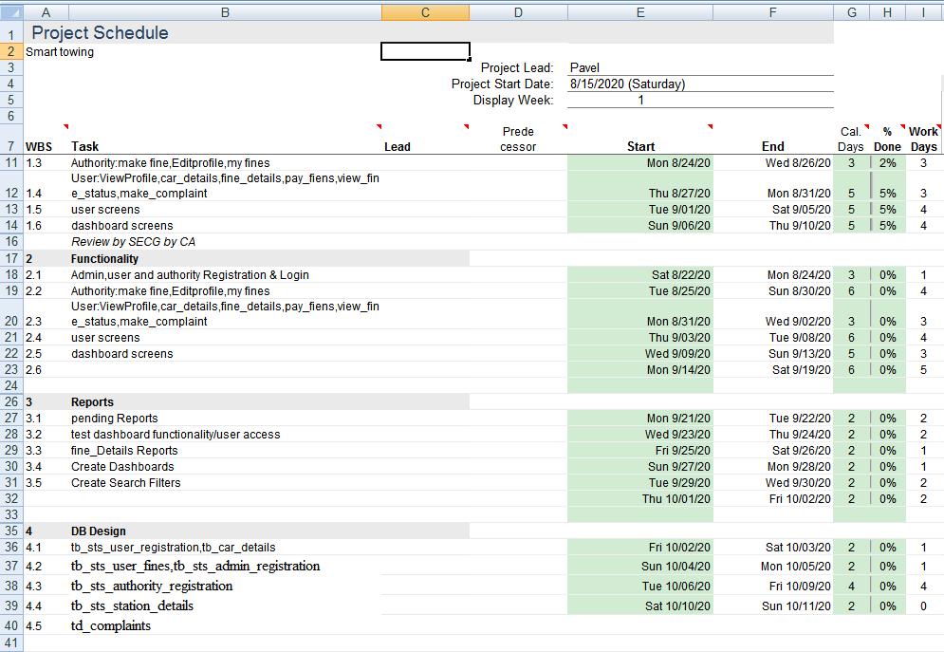

**Figure 1. Project Schedule**

A [Gantt chart](https://www.projectmanager.com/software/gantt-chart) is a graphical representation of a project schedule and it shows you the links between tasks. These are called dependencies and are normally marked with a black line.

Once we have a list of linked tasks with milestones, we can add in any fixed dates. For example, many project management applications will automatically schedule your project to start today, but you might be planning some work that won’t start for a few months.

So go through the dates and make sure that they are all as you would expect. we can alter them manually or add in any additional dates as required.

This is also the point to review how long each task will take. Software will generally set the task duration to whatever the default is, which could be as little as one day. Make sure that each task lasts for the right amount of time by manually changing the duration.

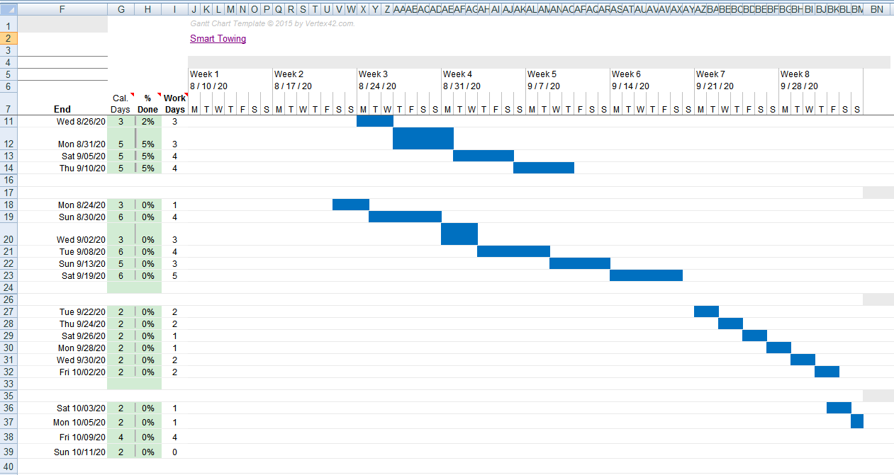

Figure. 16. Project Timeline

**CHAPTER 3**

**PROJECT SCOPE**

**3.1 PROBLEM STATEMENT**

Vehicle plays a very important role in our day to day commute. So, parking, tolls and tow are are the some of the common issues we need to deal with every day. Thus, Smart parking management [45] ,smart toll management etc. are some of the most recent works in solving such issues recently. The existing car towing is a manual process which results in keep the car owner totally unaware of this tow unless that towed vehicle is not reaching to the authority location. Which is a huge problem for the car owner. So, we can make the existing system digital and smooth by creating an app which will let the user know if their car is towed by sending them specific notification. But one thing is common for all of these smart parking, tolls or towing is we need to successfully identify the vehicle’s numberplate from the car image. So, an ML based number plate module is required here. But, as building an model which can detect any kind of numberplate is challenging as the shape, size and fronts of the numberplates vary from region to region from county to country.

This identified problem is one that has not been solved yet. This is the core of the concept of this project. So, we have proposed a new algorithm that will solve this problem of detecting numberless which we can incorporate in our smart towing app for detecting plates directly from the mobile camera.

We have addressed both the towing problem and the number plate detection problem and both of this needs to be solved in order to make a smart towing app.

**3.2 SCOPE**

The project aims at achieving the following objectives:

1. Design and developing Machine learning based models that can i detect a numberplate from an image from any kind of Numberplates (independent of regions) .
2. Development of a Smart Towing app that will
   1. Give notification to the car owner if his vehicle is towed by the authority.
   2. This includes study on how the check car fines is being done, process involved and opportunity that exists for improvement.
   3. Android used for the development of the application.
   4. Authority will be able to use the system effectively.
   5. Mobile platform means that the system ease to use and will be available for access 24/7 except when there is a temporary server issue which is expected to be minimal.
   6. It increases the efficiency of the management at offering quality services to the customers.
   7. It provides custom features development and support with the software
   8. Display the result of the ML model from camera images and uploads.
   9. Provide a client-server application that will work across the network.

This section describes the features which are in the scope of the developed application.

1. View the main screen with options
   * + User login - For Users.
     + Authority login - For existing Authority's login.
     + Admin login - For Admin.
2. Authority Login

Upon login Authority can view a Dashboard with options

* Home screen
* View Profile
* Make fines
* Scan number for checking
* View fines history and status

1. Admin Login

Upon login Admin can view a Dashboard with options

* Home screen
* Add or register, modify and delete Authority(Authority role)
* View Fines
* View Pending transactions
* View Authority list
* Authorize cars
* View User Complaints

1. Upon registration, the Admin can register Authority by using their name, username, password, mobile number and email address. The details are stored in the database.
2. Upon giving the valid credentials, the Authority will be successfully registered with the application. Now the Authority can log in and use all the features of the application.
   1. **PROJECT OBJECTIVES AND GOALS**

The Smart Towing app with number plate detection module for the vehicle was proposed to achieve mainly three goals: One, to solve the existing manual towing system by making this process fully digital. Two, provide an interface for the machine learning module for detecting numberplates. Three, To make a comparison between how The ML module work in real-life scenario(server-client) vs the local devices.

As mentioned before, this project will replace most of the traditional ways of towing system. Also, this project can be improved in the future which can be used to make a centralized towing system throughout the country.

**CHAPTER 4**

# LITERATURE REVIEW

**4.1 BACKGROUND**

We use vehicle for our daily commute. So, we face issues regarding parking tolls, tow. During past decades lots of work has been done in the field of Machine Learning. Now, the treads is to solve each of the social problem with the help of machine learning. Recently I have come across some work like Automatic parking fee collection using Automatic Number plate recognition system.[45] Technology has made this possible in many ways to provide solution for many of this vehicle related issues. The License Plate Detection requires Image processing. If we want to achieve higher accuracy, we need to precisely choose a good Machine Learning models. On the software part, any smart management Like: parking and towing we need to build a system on such a platform which is widely used and easy to get. Moreover, easy to deploy and maintain. And fortunately, android provides all these criteria. The idea is to build a number plate recognition module which will work perfectly on any random kind of numberplate from different regions with minimal computational time. Moreover, a Smart Towing app that will not only house this numberplate recognition module and act as a frontend but also solve the existing issues regarding Manual towing system. How this can be accomplished?

Number plate detection module is closely related to image processing and character recognition scheme. Character recognition can be done many ways one of the simplest ways is to use any kind of OCR like Pytesseract. But all these OCR modules come with limitations and licensing issues.

So, the best thing would be using a simple Machine Learning model with higher performance. As we want to keep our memory small and we have only few kinds of Letter front being used in the number plate characters [4]. So, we have a very small training data set. So, a KNN model will be perfectly suited here.On the later part of this chapter we will go through the bachgrounds of KNN model and Android development in details.

## **4.2 Introduction to Android**

*Basics* **-** Android is the new version where we use the java language to develop a rich application for android phones. The below Figure 1 gives us a basic structure how this device is designed from the Linux kernel to application layer.

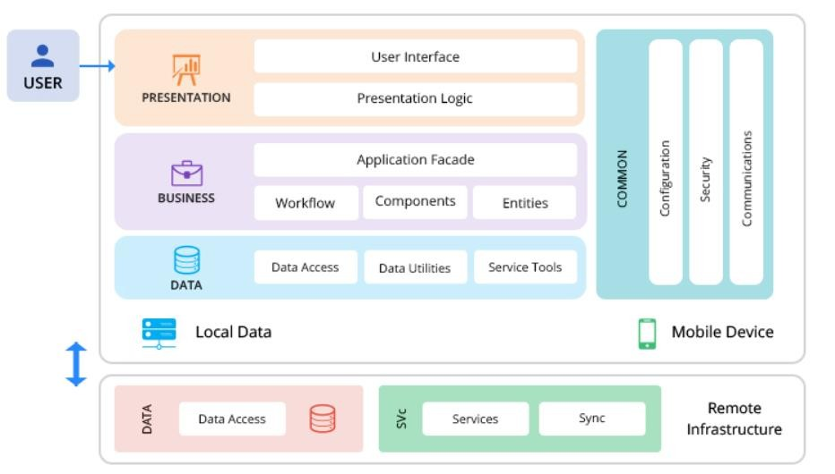

Figure.1. Android OS Architecture

*Android Architecture*–This is explained in Section 1 with details description of the android architecture.

**1. Presentation layer**

* This layer comprises UI Components and UI Process Components (Views and Controllers).
* Being at this layer, the team has to define the way the mobile app will present itself in front of the end users.
* On this layer deciding the features and their location is primarily focused.
* However, simultaneously, the team also decides other aspects like the theme, font size etc.

**2. Business layer**

* As the name suggests, the layer focuses on the business front. In simple language it focuses on the way business will be presented in front of the end users.
* This includes workflows, business components, and entities beneath the hood of two sub-layers named Service and Domain model layer.
* Service layer : focuses on defining a common set of application functions that will be available to client and end users.
* Domain model layer : represents expertise and knowledge linked to the specific problem domain.

**3. Data layer**

* At this third stage data related factors are kept in mind. This includes Data access components, data helpers/utilities, and service agents.
* Here one thing that you need to keep in mind that the three components sit under the two subheads, precisely, persistence layer and Network layer.
* Persistence layer: provides simplified access to data, which can be stored in a persistent storage or backend.
* Network layer: responsible for networking calls.

**4.3 BUILD CONSIDERATIONS**

**1. Determining the device**

* Here you need to keep the device types in mind.
* This cover
* Screen size,
* CPU characteristics,
* Resolution (DPI),
* Storage space and memory,
* Development tool environment availability.
* Some features required by the application may be available specifically to a device hardware or the OS and its version and hence at the time of building app architecture you need to have the knowledge of devices that the app will support.

**2. Considering bandwidth**

* There are times when connectivity is either intermittent or not available.
* Your app architecture needs to be built keeping in mind the worst network scenarios.
* Design your caching, data access mechanism, and state management considering times of intermittent connectivity.
* Batch multiple communications and choose software and hardware based on it.

**3. Defining user interface**

* Keep your user Interface as simple as possible. It has been noticed that a muddled UI becomes a major reason behind a mobile application’s failure.
* The smaller screen size and touch screen controls create special considerations in UI design to ensure usability, readability and consistency.
* In a mobile interface, symbols may be used more extensively and controls may be automatically hidden until accessed.
* It’s important to recognize that the object of a UI is to facilitate use of content and apps, not just use of the interface.

**4. Navigation methods**

* This one again comes on the design front. However, it requires expertise in both front and back end.
* There are numerous ways to navigate through app features, it is important for you to analyze which one’s good for your mobile application.
* The list includes:
* Single view
* Stacked navigation Bar
* Tab controller
* Scroll views
* Search driven
* Model controller
* Gesture-based
* Understand your customers and the app requirement and according chose the navigation method as it directly impacts your user experience.

**4.4 ANDROID PROJECT ARCHITECTURE**

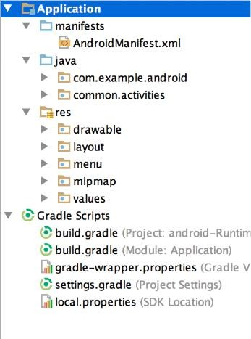

**Manifests:**

Contains the AndroidManifest.xml file.

**Java:**

Contains the Java source code files,

including JUnit test code.

**Res:**

Contains all non-code resources,

such as XML layouts, UI strings,

and bitmap images.

Figure.2. Project Architecture

**Mainfest.xml**

* Manifest file for an android application is a resource file which contains all the details needed by the android system about the application.
* It is a key file that works as a bridge between the android developer and the android platform.
* Helps the developer to pass on functionality and requirements of our application to Android.
* Should be placed at application root.
* Every Android app must have AndroidManifest.xml file. It allows us to define,
* The packages, API, libraries needed for the application.
* Basic building blocks of application like activities, services and etc.
* Details about permissions.
* Set of classes needed before launch.

**Mainfest.xml: Elements**

Following are the elements that can appear in AndroidManifest.xml, this list is restricted and we cannot add our own elements to it.

* <action>
* <activity>
* <application>
* <grant-uri-permission>
* <intent-filter>
* <permission>
* <service>
* <uses-sdk>
* <uses-permission>
* Etc.

**Some Elements for Application Properties**

* **uses-permission –** used to specify permissions that are requested for the purpose of security.
* **permission –** used to set permissions to provide access control for some specific component of the application.
* **uses-sdk –** specifies the platform compatibility of the application.
* **uses-configuration –** specifies set of hardware and software requirement of the application.
* **uses-feature –** specifies single hardware and software requirement and their related entity.
* **supports-screens, compatible-screens –** both these tags deals with screen configuration mode and size of the screen and etc.

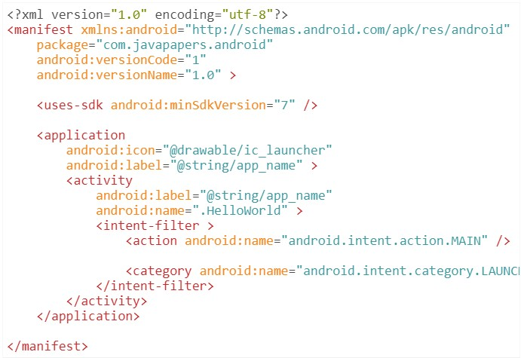

Figure.3. Manifest

**Resources Directory ( /res )**

* Resources are the additional files and static content that your code uses, such as bitmaps, layout definitions, user interface strings, animation instructions, and more.
* Externalizes app resources such as images and strings from your code, so that you can maintain them independently.
* You should also provide alternative resources for specific device configurations, by grouping them in specially-named resource directories.
* At runtime, Android uses the appropriate resource based on the current configuration.

**Resource Directory types:**

* You should place each type of resource in a specific subdirectory of your project's res/ directory.
* For example, here's the file hierarchy for a simple project.

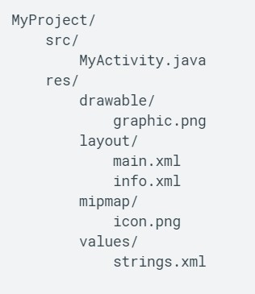

Figure.4. Project Folder Structure

**anim/** XML files that define tween animations.

**color/** XML files that define a state list of colors

**drawable/** • Bitmap files (.png, .9.png, .jpg, .gif)

• XML files that are compiled into the following drawable resourcesubtypes: Bitmap files

* Nine-Patches (re-sizable bitmaps)
* State lists
* Shapes
* Animation drawables
* Other drawables

**font/** Font files with extensions such as .ttf, .otf, or .ttc, or XML files that include a <font-family> element. For more information about fonts as resources.****

**mipmap/** Drawable files for different launcher icon densities.

**layout/** XML files that define a user interface layout xml/

• Arbitrary XML files that can be read at runtime by calling Resources.getXML().

• Various XML configuration files must be saved here, such as a searchable configuration.

**menu/** XML files that define app menus, such as an Options Menu, Context Menu, or Sub Menu.

**R.java**

* Is an auto-generated file by aapt (Android Asset Packaging Tool) that contains resource IDs for all the resources of res/ directory.
* If you create any component in the activity_main.xml file, id for the corresponding component is automatically created in this file. This id can be used in the activity source file to perform any action on the component.

**VIEWS**

* The View is a base class for all UI components in android and it is used to create an interactive UI components such as TextView, EditText, Checkbox, Radio Button, etc.
* A View usually draws something the user can see and interact with.
* The ViewGroup is a subclass of View and it will act as a base class for layouts and layout parameters. The ViewGroup will provide an invisible container to hold other Views or ViewGroups and to define the layout properties.
* In android, we can define a UI or input controls in two ways, those are
* Declare UI elements in XML
* Create UI elements at runtime

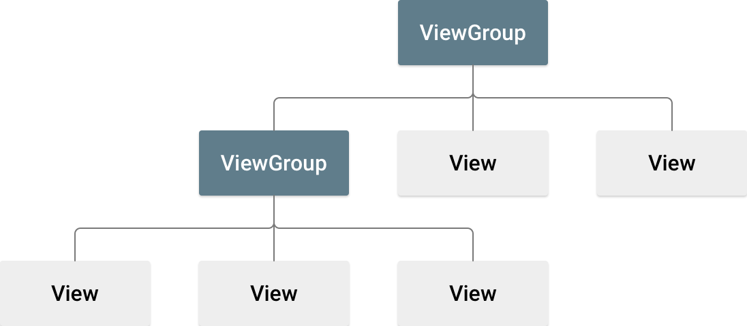

Figure.5. View Group structure

**EXAMPLE XML FILE**

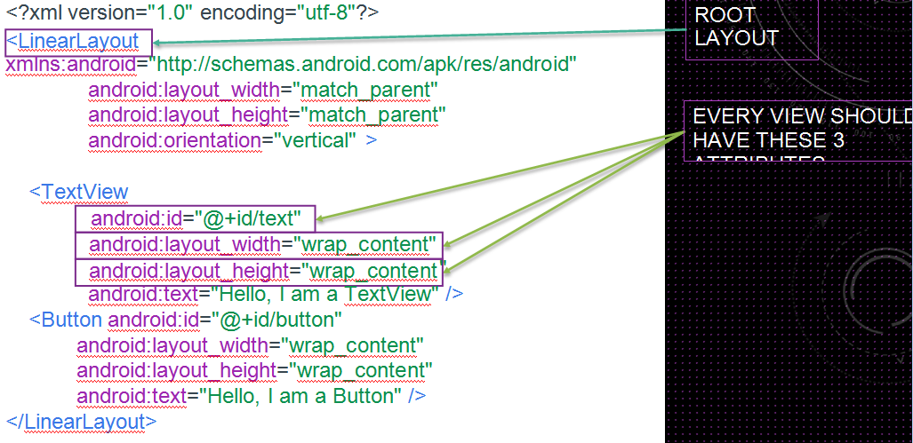

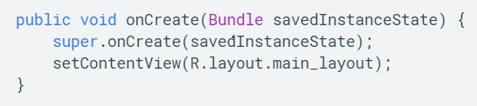

* When you compile your app, each XML layout file is compiled into a View resource.
* You should load the layout resource from your app code, in your Activity.onCreate() callback implementation.
* Do so by calling setContentView(), passing it the reference to your layout resource in the form of: R.layout.layout_file_name.
* The onCreate() callback method in your Activity is called by the Android framework when your Activity is launched

**ATTRIBUTES**

* Every View and ViewGroup object supports their own variety of XML attributes.
* Some attributes are specific to a View object (for example, TextView supports the textSize attribute), but these attributes are also inherited by any View objects that may extend this class.
* Some are common to all View objects, because they are inherited from the root View class (like the id attribute). And, other attributes are considered "layout parameters," which are attributes that describe certain layout orientations of the View object, as defined by that object's parent ViewGroup object.

**ID**

* 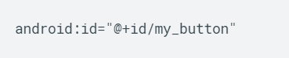Any View object may have an integer ID associated with it, to uniquely identify the View within the tree. When the app is compiled, this ID is referenced as an integer, but the ID is typically assigned in the layout XML file as a string, in the id attribute.
* The at-symbol (@) at the beginning of the string indicates that the XML parser should parse and expand the rest of the ID string and identify it as an ID resource. The plus-symbol (+) means that this is a new resource name that must be created and added to our resources (in the R.java file).

**LAYOUT PARAMETERS**

* All view groups include a width and height (layout_width and layout_height), and each view is required to define them. Many LayoutParams also include optional margins and borders.
* You can specify width and height with exact measurements, though you probably won't want to do this often. More often, you will use one of these constants to set the width or height:
* wrap_content tells your view to size itself to the dimensions required by its content.
* match_parent tells your view to become as big as its parent view group will allow.
* In general, specifying a layout width and height using absolute units such as pixels is not recommended. Instead, using relative measurements such as density-independent pixel units (dp), wrap_content, or match_parent, is a better approach, because it helps ensure that your app will display properly across a variety of device screen sizes.

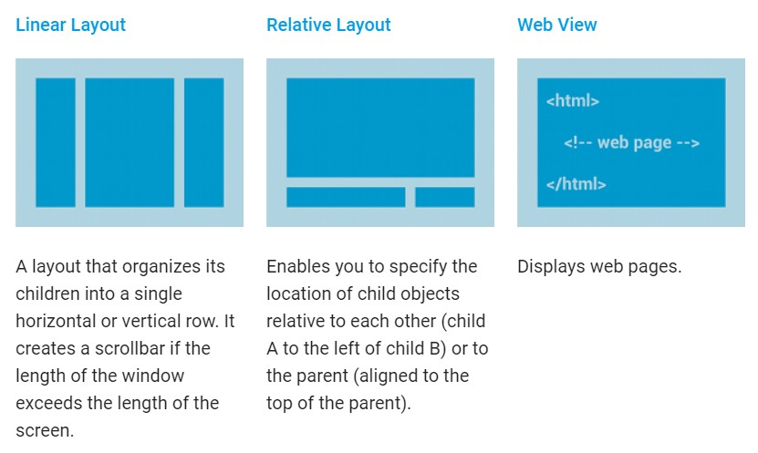

Figure.6. Different Layouts

**ADAPTERS**

* When the content for your layout is dynamic or not pre-determined, you can use a layout that subclasses AdapterView to populate the layout with views at runtime.
* 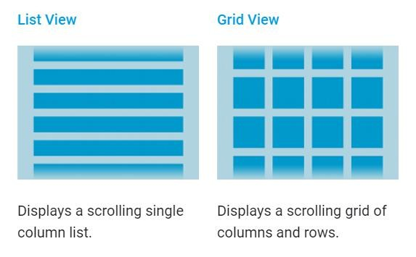A subclass of the AdapterView class uses an Adapter to bind data to its layout. The Adapter behaves as a middleman between the data source and the AdapterView layout—the Adapter retrieves the data (from a source such as an array or a database query) and converts each entry into a view that can be added into the AdapterView layout.

Figure.7. User Views

**ACTIVITIES**

* Most apps contain multiple screens, which means they comprise multiple activities. Typically, one activity in an app is specified as the main activity, which is the first screen to appear when the user launches the app.
* An activity provides the window in which the app draws its UI. This window typically fills the screen, but may be smaller than the screen and float on top of other windows.
* Generally, one activity implements one screen in an app. For instance, one of an app’s activities may implement a Preferences screen, while another activity implements a Select Photo screen.
* Each activity can then start another activity in order to perform different actions. For example, the main activity in a simple e-mail app may provide the screen that shows an e-mail inbox.
* From there, the main activity might launch other activities that provide screens for tasks like writing e- mails and opening individual e-mails.

**Declare activities**

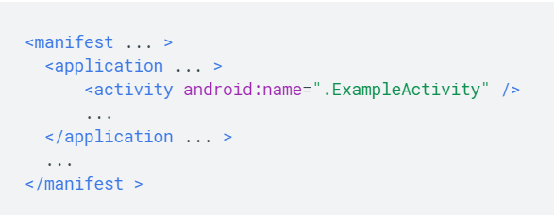To declare your activity, open your manifest file and add an <activity> element as a child of the <application> element. For example:

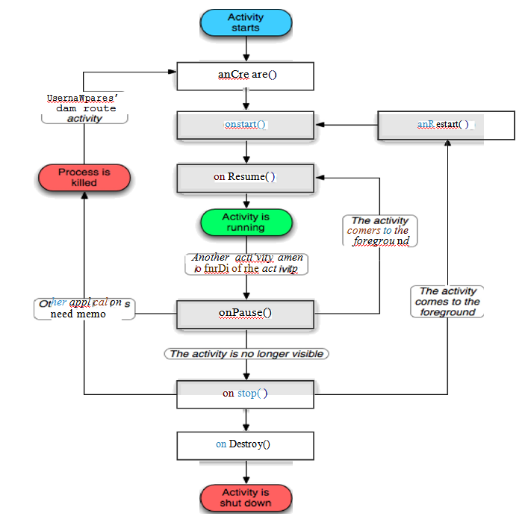

Figure. 8. Android Life Cycle

**onCreate()**

* You must implement this callback, which fires when the system creates your activity. Your implementation should initialize the essential components of your activity: For example, your app should create views and bind data to lists here. Most importantly, this is where you must call setContentView() to define the layout for the activity's user interface.
* When onCreate() finishes, the next callback is always

**onStart()**

* As onCreate() exits, the activity enters the Started state, and the activity becomes visible to the user. This callback contains what amounts to the activity’s final preparations for coming to the foreground and becoming interactive.

**onResume()**

The system invokes this callback just before the activity starts interacting with the user. At this point, the activity is at the top of the activity stack, and captures all user input. Most of an app’s core functionality is implemented in the onResume() method.

**onPause()**

* The system calls onPause() when the activity loses focus and enters a Paused state. This state occurs when, for example, the user taps the Back or Recents button. When the system calls onPause() for your activity, it technically means your activity is still partially visible, but most often is an indication that the user is leaving the activity, and the activity will soon enter the Stopped or Resumed state.
* An activity in the Paused state may continue to update the UI if the user is expecting the UI to update. Examples of such an activity include one showing a navigation map screen or a media player playing. Even if such activities lose focus, the user expects their UI to continue updating.

**onStop()**

* The system calls onStop() when the activity is no longer visible to the user. This may happen because the activity is being destroyed, a new activity is starting, or an existing activity is entering a Resumed state and is covering the stopped activity. In all of these cases, the stopped activity is no longer visible at all.
* The next callback that the system calls is either onRestart(), if the activity is coming back to interact with the user, or by onDestroy() if this activity is completely terminating.

**onRestart()**

* The system invokes this callback when an activity in the Stopped state is about to restart. onRestart() restores the state of the activity from the time that it was stopped. • This callback is always followed by onStart().

**onDestroy()**

* The system invokes this callback before an activity is destroyed.
* This callback is the final one that the activity receives. onDestroy() is usually implemented to ensure that all of an activity’s resources are released when the activity, or the process containing it, is destroyed.
* This section provides only an introduction to this topic. For a more detailed treatment of the activity lifecycle and its callbacks, see The Activity Lifecycle.



## **4.5 Debugging and Testing**

*Debugging* - is a cyclic movement including execution testing and code revision. The testing that is being finished amid investigating has an unexpected point in comparison to conclusive module testing. Last module testing means to show rightness, while testing amid troubleshooting is basically gone for finding blunders. This distinction significantly affects the decision of testing procedures.

*Testing* – incorporates checking right conduct of the module. Testing is done at all phases of module improvement: prerequisites examination, interface structure, calculation plan, execution, and coordination with different modules. In the accompanying, consideration will be aimed at usage testing. Usage testing isn't confined to execution testing. A usage can likewise be tried utilizing accuracy proofs, code following, and companion audits, as portrayed beneath.

Distributing –we can release the application or a website in many different way. Most commonly used is “google play store” and if we have a domain the website can also be release related to any application.

## **4.6 Google Play Store**

Give my applications more highlights to draw in clients on a more extensive scope of gadgets. With Google Play benefits, your application can exploit the most recent, Google-controlled highlights, for example, Maps, Google+, and that is only the tip of the iceberg, with programmed stage refreshes appropriated as an APK through the Google Play store. This makes it quicker for your clients to get refreshes and simpler for you to coordinate the freshest that Google brings to table.

## 

## **4.7 PHP**

The following diagram illustrates PHP Architecture:

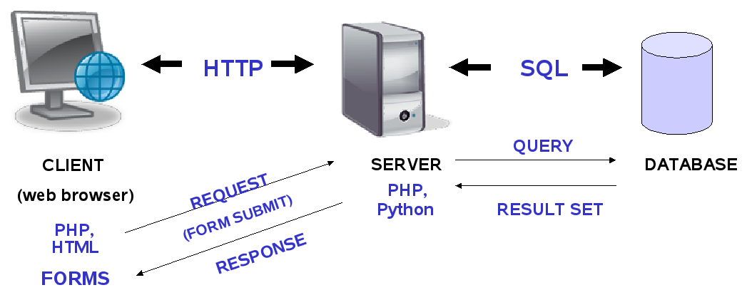

Figure. 9. PHP Architecture

## **4.8 MANAGED API COMPATIBILITY**

Programming interface the board is the way toward distributing, reporting and regulating application programming interfaces (APIs) in a safe, adaptable condition. The objective of API the executives is to permit an association that distributes an API to screen the interface is lifecycle and ensure the necessities of designers and applications utilizing the API are being met.

1. *API management software tools typically provide the following functions:*
2. *Automate and control connections between an API and the applications that use it.*
3. *Ensure consistency between multiple API implementations and versions.*
4. *Monitor traffic from individual apps.*
5. *Provide memory management and caching mechanisms to improve application performance.*
6. *Protect the API from misuse by wrapping it in security procedures and policies.*

## **COMPATIBILITY:**

Software API compatibility is checked and verified such as “intents” and “permissions”.

## **4.9 BUILD PARAMETERS**

On the **Parameters** page of Build Configuration settings, you can classify the required system properties and environment variables to be passed to the build script and environment when a build is started. Note that you can redefine them when launching a Custom Build.

Build Parameters defined in a Build Configuration are used only within this configuration. For other ways, refer to Project and Agent Level Build Parameters.

Any user-defined build parameter (system property or environment variable) can reference other parameters by using the following format:

**Intent Compatibility** - Gadget usage MUST respect Android's free coupling goal framework, as portrayed in the segments underneath. By "respected”, it is implied that the gadget implementer MUST give an Android Activity or Service that indicates a coordinating expectation channel that ties to and actualizes right conduct for each predefined aim design.

**API Behavioral Compatibility -** The Behavior API is made out of just a single interface and one class. The Behavior interface characterizes the individual conduct classes. The Behavior interface is extremely broad and characterizes three open techniques. Each undertaking that the robot must perform can be characterized in its very own class. It works very well in light of the fact that, despite the fact that the individual usage of a conduct fluctuate generally, they are altogether treated alike. When every one of the practices are made, they are given to an Arbitrator to manage which conduct ought to be enacted whenever. The Arbitrator class and the Behavior interface are found the “lejos.subsumption” bundle. The API for the Behavior interface is as per the following.

**Hardware Compatibility -**is a rundown of androidhardware (commonly including numerous sorts of fringe gadgets) that is impeccable with a particular working system or device the board programming. As of now, there is a colossal proportion of PC gear accessible for use and many working structures also. A gear closeness list is a database of hardware models and their similitude with a particular working structure.

**4.10 KNN Model:**

KNN or K nearest neighbor is a supervised machine learning model or algorithm which is very simple and easy to implement. It is very useful in both classification and regression problem. Definitely character recognition is a example of classification problem where we categorized data into character class.

Before going further, we need to know the definition of several things.

**Supervised vs Unsupervised Learning:**

In supervised learning, we simply rely on the labeled data and train the model with it. Thus, make prediction to some unlabeled data as output. On the other hand, Unsupervised learning is deals with unlabeled data and tries to find the structure of the data thus give the insight of it.

For example, parents want their kid to learn the what is cat. They shod the kid several pics of cow and tell him that it is called cow. Then if he showed any unlabeled pic looks like cow the kid can tell that. If it is another animal, he can say that it is not cow. Here this learning procedure is supervised learning. For unsupervised learning the parents showed the kid several pic of different animals like cow, dog, cat. After seeing that he can classified that in some the the pictures the animal with horn are similar and bigger than the other animals. And this insight of data is unsupervised learning.

**K-Nearest Neighbors:**

In KNN algorithm, we assume similar objects stay close to each other.[48]

**The KNN Algorithm:**

1. Load the data first.
2. Initialize K. //the number of neighbors
3. For each example in data calculate the distance between them
4. Add all the distance as collection of indexes.
5. Sort them from smallest to largest
6. Pick K entries from the collection and label it .

**KNN Overview in Character Recognition:**

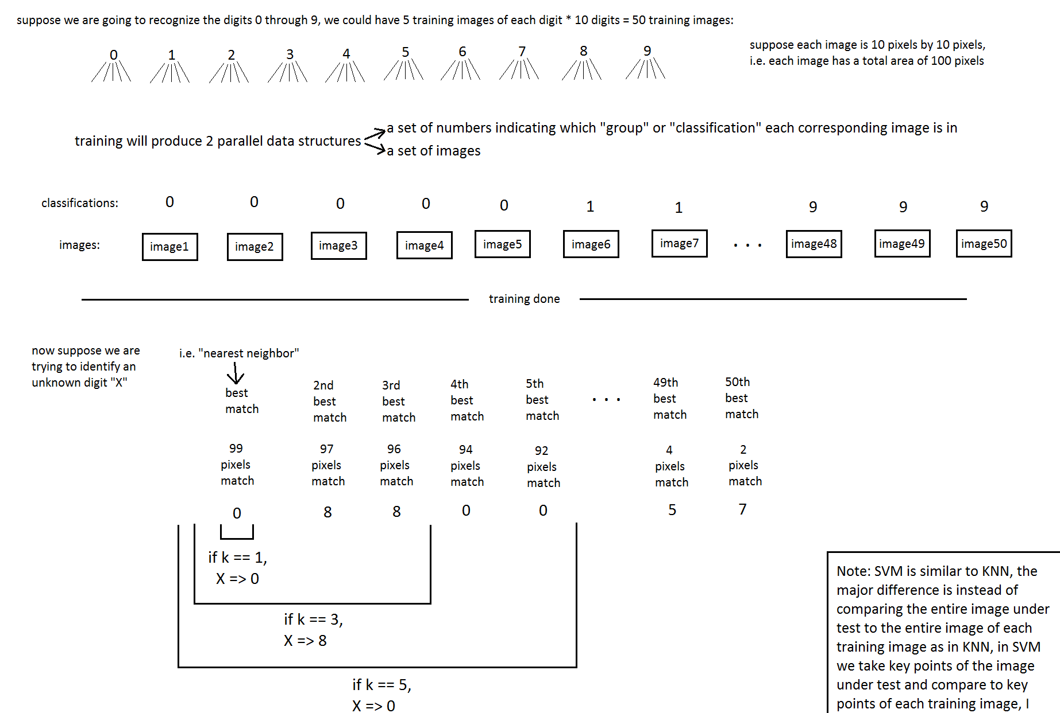

Figure 2. KNN algorithm overview [48]

**CHAPTER 5**

# METHODOLOGY

**5.1 Introduction:**

**A. Software Models**

System development methodology is an organized way of solving a problem. In software development, there are several methodologies also called software engineering models which are used in solving problems.

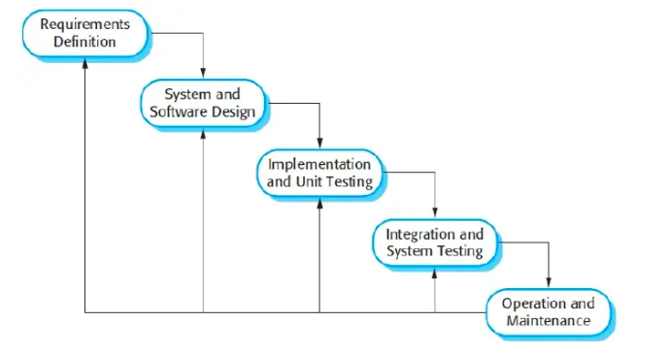

Figure 3. Methodology (Waterfall Model)

**B. Waterfall Model**

The model that I will basically follow is the waterfall model. In the waterfall model the sequence of activities performed in a software development include. Detail design Coding Unit testing System integration & testing Following is a diagrammatic representation of different phases of the waterfall model. I will choose to use the waterfall model due to the following benefits. Advantages of waterfall model.

**Discussion of Software Quality Assurance Theories and Practices related to the project development**

**Development**: In this aspect the Research and Analysis takes place where all the requirements are identified and designed according to the newly proposed algorithm.

**Baseline System**: The Design was prepared as per requirements given by the client and the prototype was developed which meets a partial functionality of the product. The testing phase will identify the bugs and negative functionality of the product.

**Production:** The future enhancements were defined in view of full functionality which leads to automating the entire process. The maintenance and service-related issues will be addressed in the production stage only. In this stage the delivery of the product will be done.

**Version Control:** The Version is the improvements added in the developed software. If a client needs to upgrade the software with advanced features then the phases of Development, Baseline System and production phases are repeatedly done.

Software testing is a prior task of software quality assurance. Testing includes the processes of finding misconfigurations, requirement evaluation, defects and fixing the identified bugs. Defected code modules can be found on code inspection and actual execution of test cases are implemented. However, the software quality assurance deals majorly with the defects that are identified in which modules but also with the correction of identified bugs. The following are the skills needed

• Understand developer’s terminologies

• Know when the code is ready for testing

• Be able to evaluate the impact of a problem on the customers.

## **5.2 System Architecture of Smart Towing app**

The System architecture of smart towing application for android phone is shown in figure.

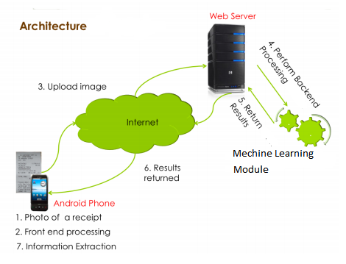

Figure. 4. System Architecture

Compared to desktop or notebook computers, mobile devices have comparatively low processing power and imperfect storage capacity. Meanwhile, mobile phone users always expect instantaneous response when interacting with their handsets. The Number Plate Recognition module is designed to minimize the processing time so as to provide real time response. We enforce real time responsiveness by adopting many strategies, including: – Designing computationally efficient algorithms to reduce processing time. – Spawning separate threads and background services for computation-intensive workloads to keep the GUI always responsive. – Using compressed image format to store and transmit image data. Figure 6 presents architectural diagram for the client software. The client software consists of 7 functional modules. By default, the client is in idle state. When the user initiates the application, the client starts up a camera preview to take a picture. The preview object implements a callback function to retrieve the data from the embedded 3.2 mega-pixel camera, which satisfies the 300dpi resolution requirement of our ML module. Client also implements an orientation handler running inside a background service thread, which is responsible for preventing users from tilting the camera beyond a threshold while taking a picture. It periodically polls the orientation sensors to get the pitch and roll values. A threshold range of [-10, 10] is set for both sensors.

This application has two essential components **the client** and **the server.** The application interacts directly with Server i.e., the SQL server.

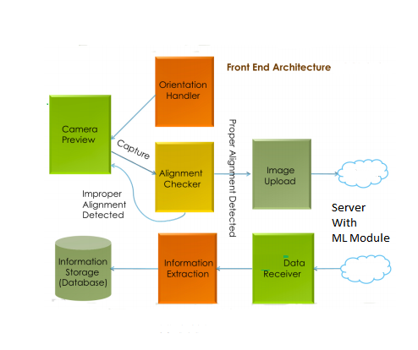

Figure. 12. Front End Architecture

**5.3 OpenCV Character Recognition**

**OpenCV** (Open source computer vision) is a library of programming functions mainly aimed at real-time computer vision. [OpenCV](https://www.geeksforgeeks.org/opencv-python-tutorial/) in python helps to process an image and apply various functions like resizing image, pixel manipulations, object detection, etc.

## **Applying image processing for the image:**

The color space of the image is first changed and stored in a variable. For color conversion we use the function cv2.cvtColor(input_image, flag). The second parameter flag determines the type of conversion. We can choose among **cv2.COLOR_BGR2GRAY** and **cv2.COLOR_BGR2HSV**. cv2.COLOR_BGR2GRAY helps us to convert an RGB image to gray scale image and cv2.COLOR_BGR2HSV is used to convert an RGB image to HSV (Hue, Saturation, Value) color-space image. Here, we use **cv2.COLOR_BGR2GRAY**. A threshold is applied to the converted image using cv2.threshold function.

There are 3 types of thresholding:

1. Simple Thresholding
2. Adaptive Thresholding
3. Otsu’s Binarization

For more information on thresholding, refer [Thresholding techniques using OpenCV](https://www.geeksforgeeks.org/python-thresholding-techniques-using-opencv-set-1-simple-thresholding/).

cv2.threshold() has 4 parameters, first parameter being the color-space changed image, followed by the minimum threshold value, the maximum threshold value and the type of thresholding that needs to be applied.

## Finding Contours:

cv2.findContours() is used to find contours in the dilated image. There are three arguments in cv2.findContours(): the source image, the contour retrieval mode and the contour approximation method.  
This function returns contours and hierarchy. Contours is a python list of all the contours in the image. Each contour is a NumPy array of (x, y) coordinates of boundary points in the object. Contours are typically used to find a white object from a black background. All the above image processing techniques are applied so that the Contours can further be used to calculate the bounding rectangle (bounding height, width, diameter, aspect ratio etc.) for each of the them. These are very important characteristics to differentiate a text from a general contour.

**5.4 Module for Detecting Number Plates**

Number Plate detection is one of the most popular problem around the world. It is quite challenging since the number plates around the world can be varied from countries to countries and region to region. In United States for example, each of the 50 states has their own number plates. Moreover, almost every state has old and new versions of number plates

Which results in further confusion, ambiguity and challenges. So, we are mainly proposing a general technique which can be used to detect license number/Registration number from every kind of number plate.

To fund the registration number from a number plate we have divided our problem int two module.

* Detecting the license plate/ Find plate.
* Detecting the char within the plate.

**Detecting the Number Plate**

To detect a number plate, we first input an image and the turn it into gray scale and thus draw the contours of that images. Then we called a function named findpossiblecharinthescene ().

What it does is applying several conditions to check if a contour can be considers as character. *The steps of findpossiblecharinthescene ():*

1. *Calculate the minimum bounding box for each of the contours.*
2. *For each contour:*

*if (possibleChar.intBoundingRectArea> MIN_PIXEL_AREA and possibleChar.intBoundingRectWidth> MIN_PIXEL_WIDTH and possibleChar.intBoundingRectHeight> MIN_PIXEL_HEIGHT and MIN_ASPECT_RATIO <possibleChar.fltAspectRatio and possibleChar.fltAspectRatio< MAX_ASPECT_RATIO):*

*return True*

*else return False*

Here, we have taken MIN_PIXEL_AREA=0.2 or 20%. So, we have assumed that if a contour should be considered as a possible character only if there is at least 20% of pixel present in its bounding box. We have also assumed the minimum width of a pixel should be at least 3 pixel and minimum height should be at least 4 pixels. Otherwise, any char can’t be drawn. Furthermore, the aspect ratio should be within the range of 25% and 100%. Where .



After applying this filter, we get a picture of reduced contours. Thus, we again apply another filter findListOfListsOfMatchingChars () for further reduction of unnecessary contours and extract plates.

*The steps of findListOfListsOfMatchingChars ():*

1. *For each of the remaining contour:*

* *Calculate change in area, change in height, change in width*
* *if (fltDistanceBetweenChars< (possibleChar.fltDiagonalSize * MAX_DIAG_SIZE_MULTIPLE_AWAY) and fltAngleBetweenChars< MAX_ANGLE_BETWEEN_CHARS and fltChangeInArea< MAX_CHANGE_IN_AREA and fltChangeInWidth< MAX_CHANGE_IN_WIDTH and fltChangeInHeight< MAX_CHANGE_IN_HEIGHT):*
* *listOfMatchingChars.append(possibleChar)*

*# if the chars are a match, add the current char to list of matching chars*

1. *for eachpossibleChar in listOfPossibleChars:*

* *if len(listOfMatchingChars) < MIN_NUMBER_OF_MATCHING_CHARS:*

*return true*

Here, we have taken *MAX_DIAG_SIZE_MULTIPLE_AWAY*=5 pixels. So, each of the characters should be considered as the characters in the numberplates if and only if they are within 5 pixels apart. Moreover, angle between two characters shouldn’t be more than 12.5 degree. And the change of height, width and area should not be more than 20%, 80% and 50% respectively.

After this check, for each *possibleChar* in *listOfPossibleChars*, we check if the length of the sting is <MIN_NUMBER_OF_MATCHING_CHARS. We assume the MINNUMBEROFMATCHINGCHARS is 3. Anything less than 3 characters should not be considered as a number plate in our method.

As this filtering requires heavy computation. Thus, to reduce the computational time We have divided this filtering into two steps. After this we extract each of the image regarding the each of the possible plates. Next we move onto detecting the characters in these possible plates and find the actual plates.

**Steps of Finding a number plate:**

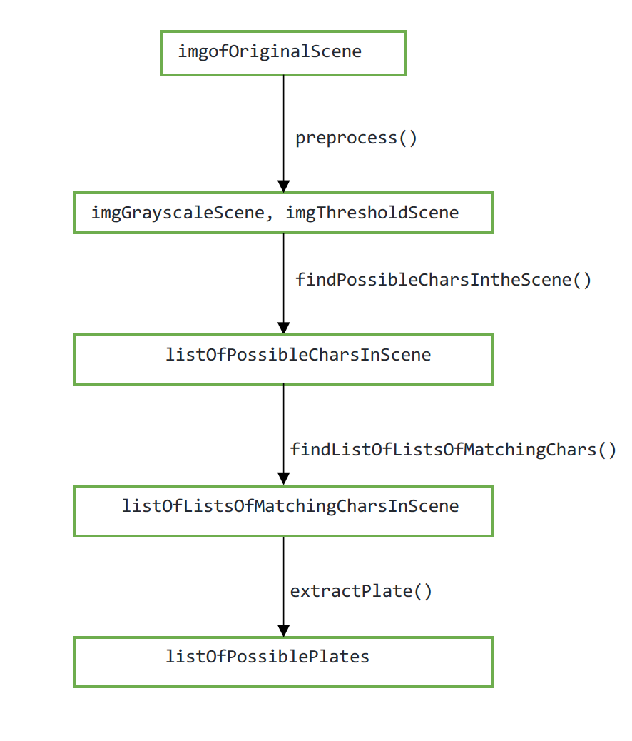

Figure. 13. Steps for finding numberplates

**Detailed Steps of Finding a number plate:**

**Step 1: Image Preprocessing**

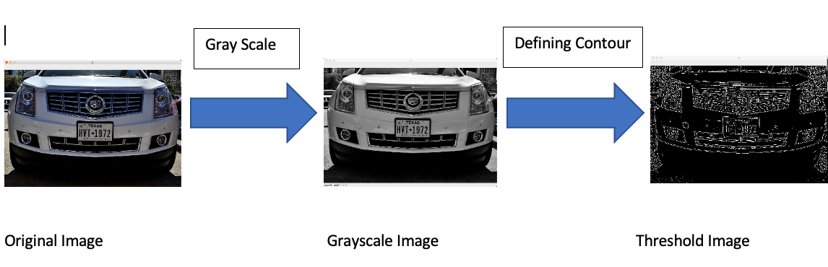

**Figure. 14. Image Preprocessing**

**Step 2:** **Finding Possible Characters**

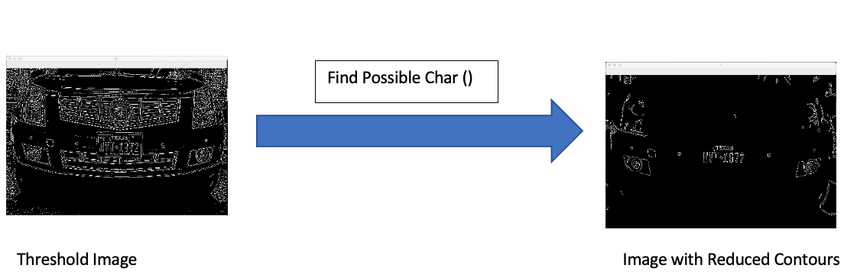

**Figure 15. Unnecessary contours removed**

**Step 3: Finding list of the list of Matching Character**

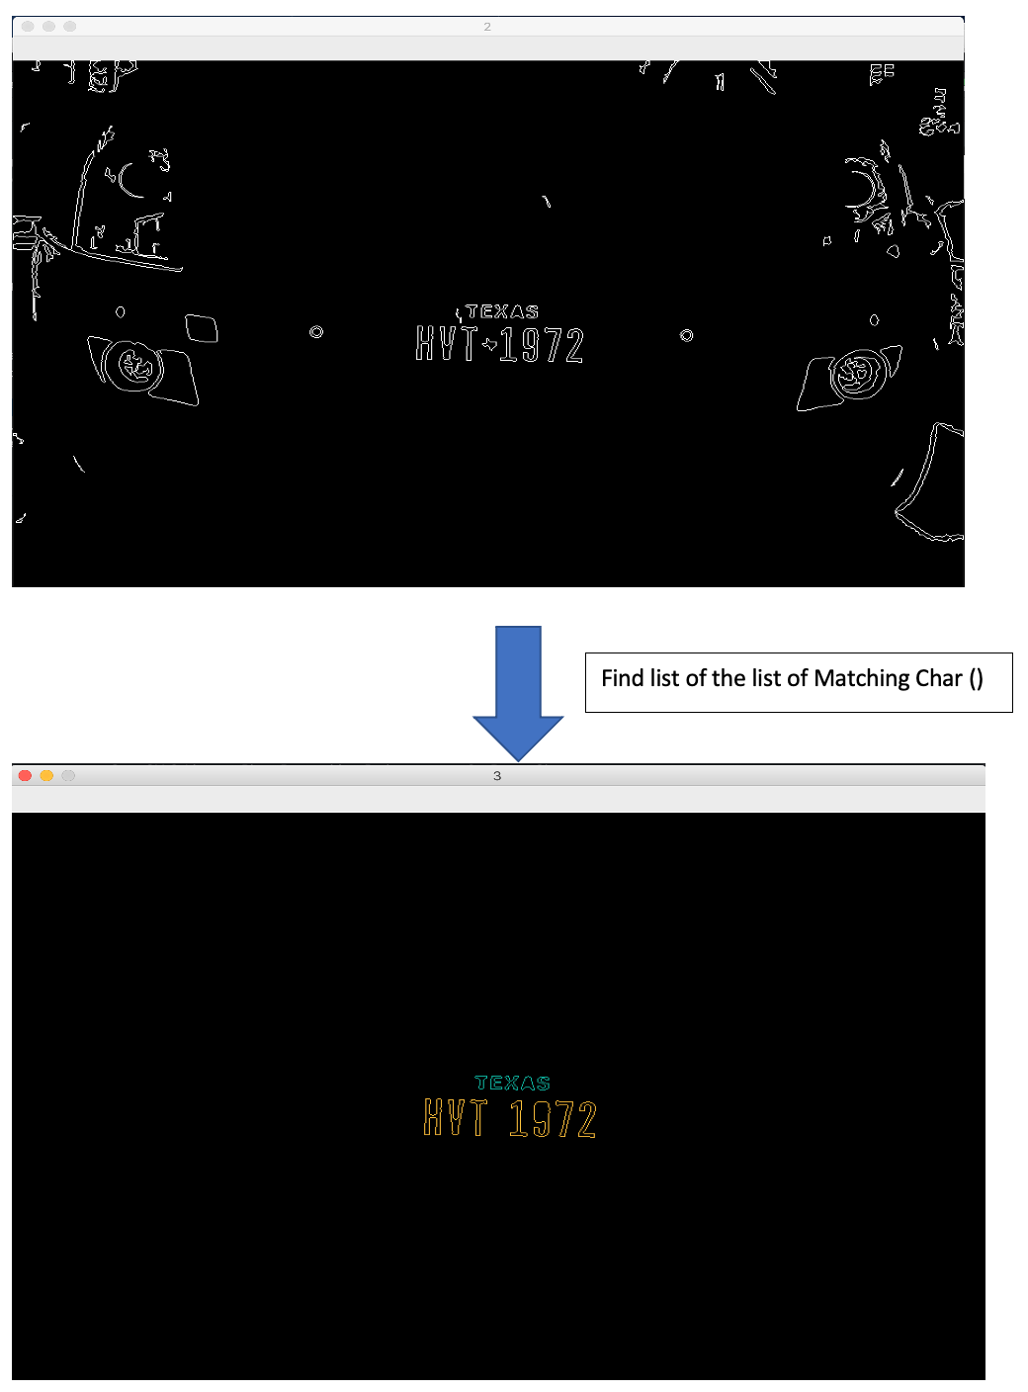

**Figure 16. Finding list of the list of Matching Character**

**Step 4: Extract Possible Plates:**

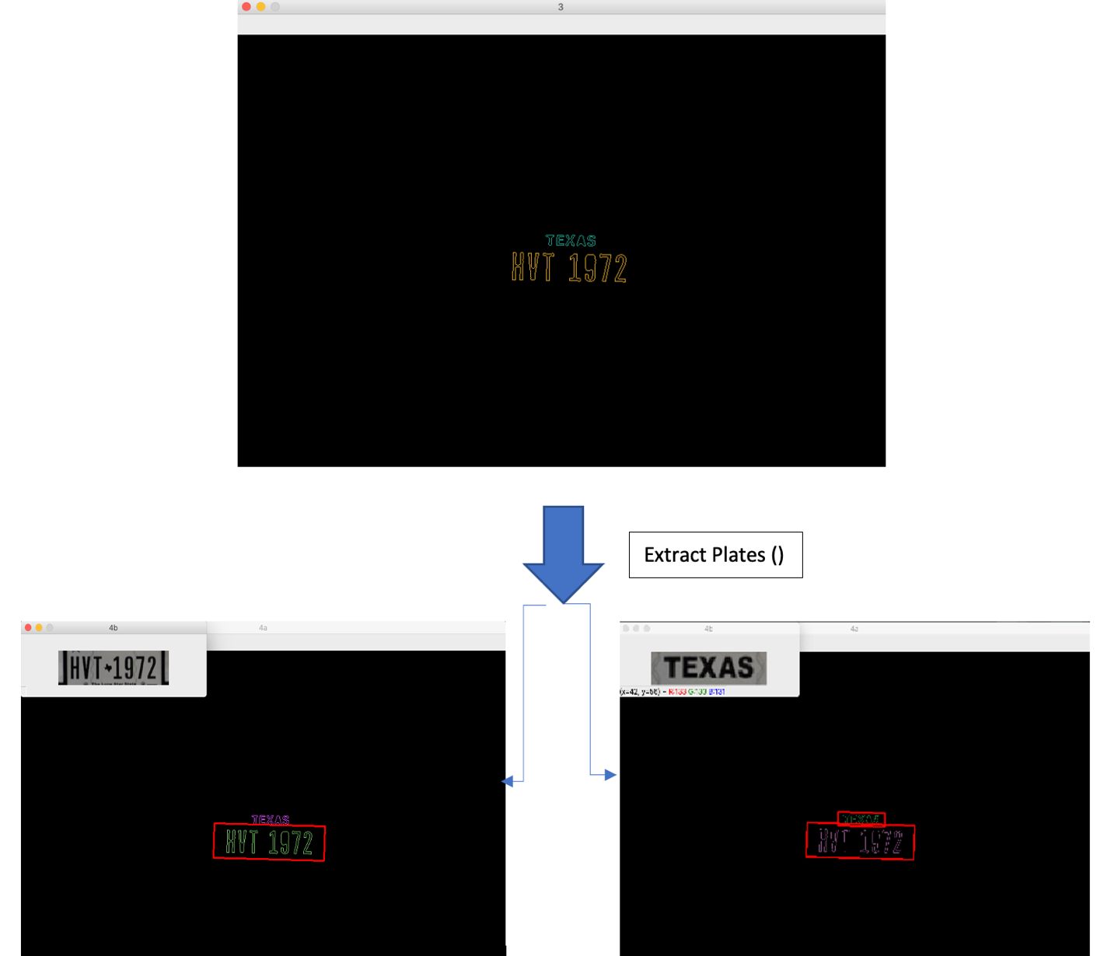

Figure 17. Extract Possible Plates

**Detection Characters in the Number Plate**

After getting the list of possible plates, we further process each possible plate for finding characters in them. We have also checked the inner overlapping characters and remove them by applying remove Inner Overlapping chars() function. Thus, we have used a pre trained KNN-algorithm here for fetching the characters out of each plate. Finally, we assumed that the plate containing the maximum number of characters is the actual plate.

**Steps of find Characters within plate**

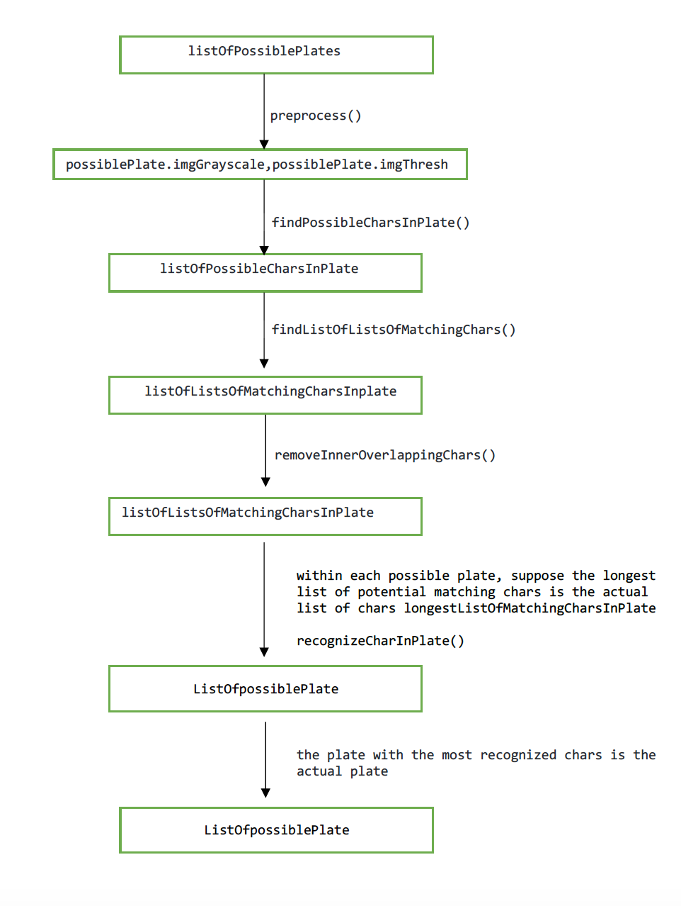

Figure. 14. Steps for finding Characters

Step 1:

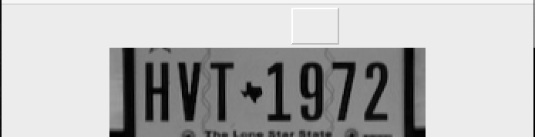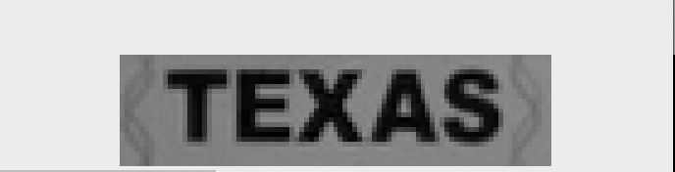

Preprocess ()



Step 2:

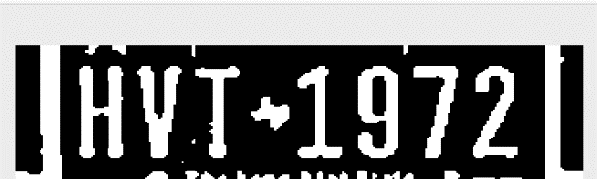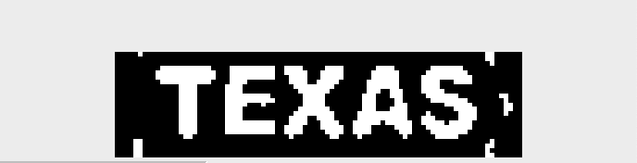

Find possible char in plate ()

Step 3:



Remove Overlapping ()

Step 4:



Recognize Plate ()

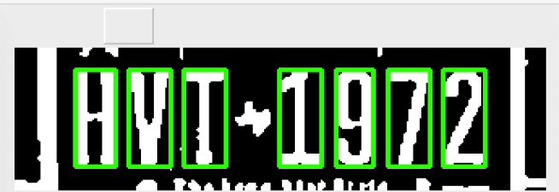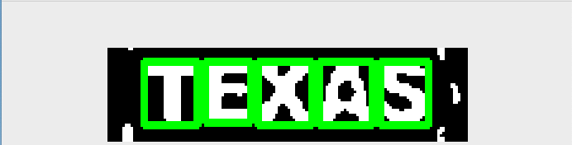

Step 5:

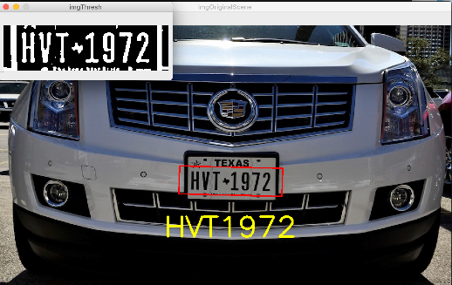

Final Output

**Figure 18. Steps of finding characters in plates**

**5.5 Result Evaluation**

For testing our module, we have used 10, 20,40,80,160 of random number plates from various regions. And we have got some significant results both with the execution time and accuracy.

We are showing some testing data below:

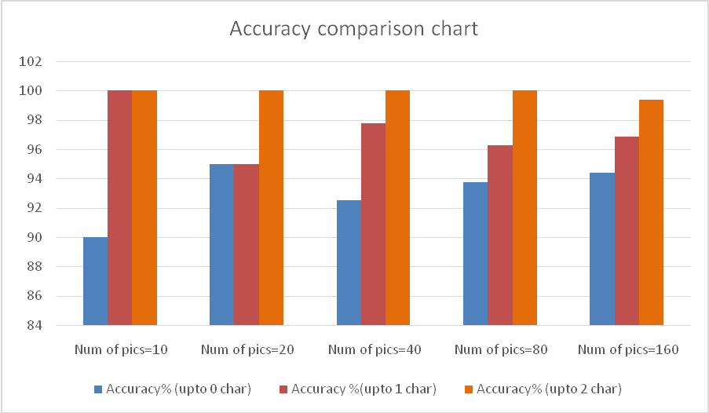

Figure. 14. Accuracy comparison chart

Our average execution time is around 10ms for detection the number plates from an image which is significantly faster than some industrial grade license detector like OpenAlpr [12].But in the app we are getting significantly less execution time due to the server client communication overhead. In the figure below we have shown the execution time of the module for 10 different pictures both locally and inside the application(from server)

Figure 15. Actual Execution time vs Execution time in app

**Image with noise:**

Our proposed method of license plate detection works very well in images ith noise. It is due to removing unnecessary contour. Thus, we are actually thrown away most of the noise from the picture.

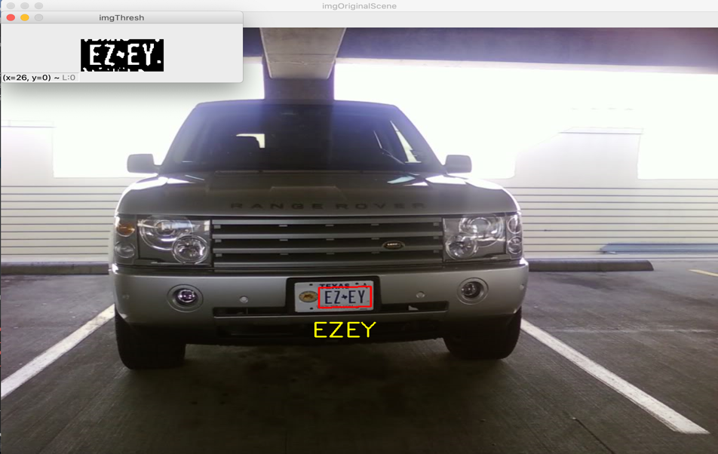

Figure 16. Numberplate detection from Image with noise

**Some Failed Scenario:**

In some of images our model failed to detect the number plate characters correctly. Though the plate detection itself was 100% accurate.

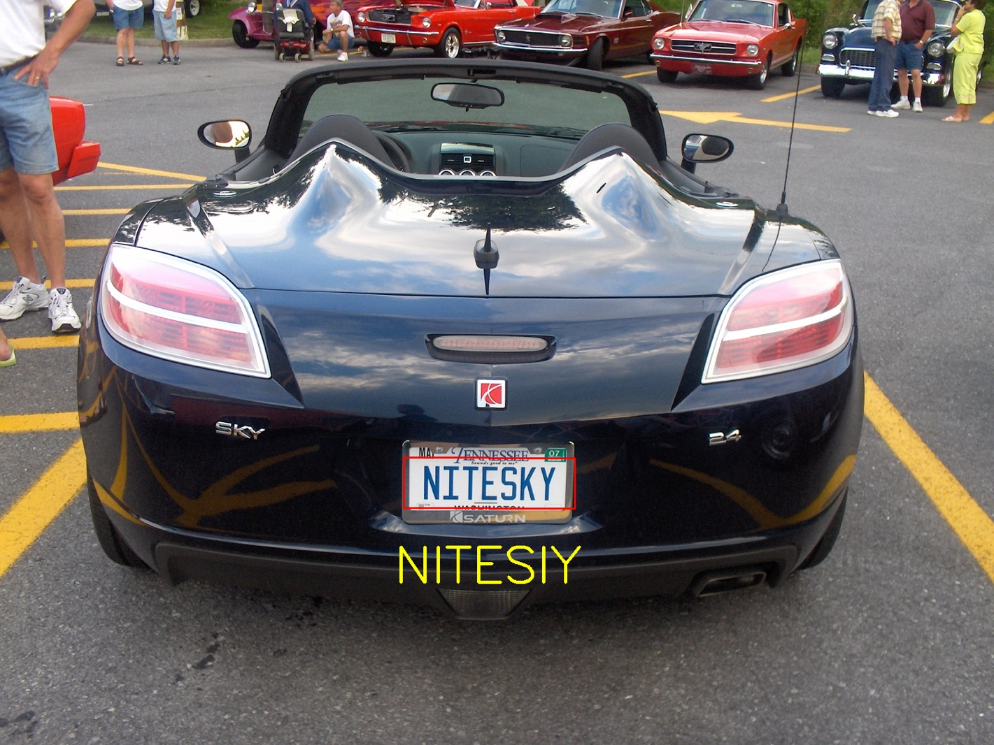

Figure 17. Wrong prediction

Here, we can see that our algorithm complete misinterpreted the letter ‘K’ as letter ‘I’. If we see the threshold image (Fig. 18) a bit, we can easily understand why our module made such error. It’s because the threshold algorithm of OpenCV simply slash the character “K” thus the first half if the character is closer to “I” so it has been taken as “I”.

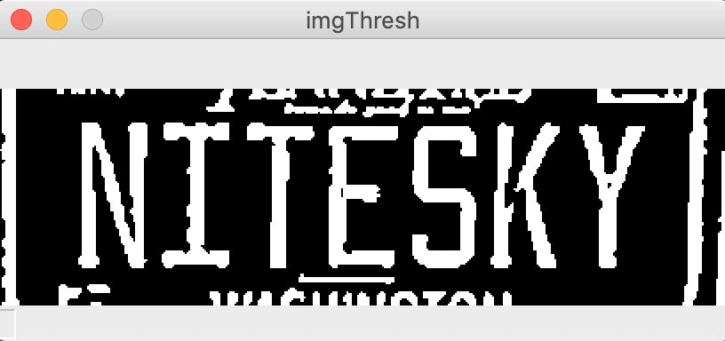

Figure 18. Threshold image

**CHAPTER 6**

**SYSTEM ANALYSIS MODELS**

**5.1 Use Case Diagrams**

A use case diagram at its simplest is a representation of a user's interaction with the system that shows the relationship between the user and the different use cases in which the user is involved.

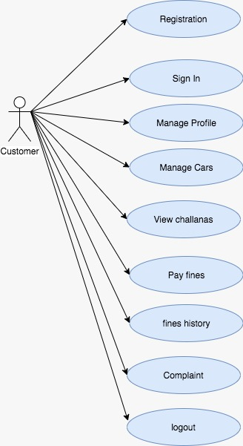

figure 17: Use case Diagram for User

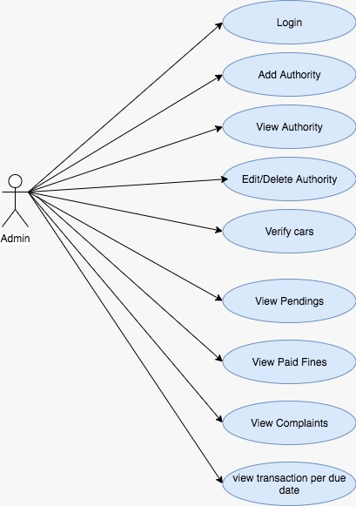

figure 18: Use case Diagram for Admin

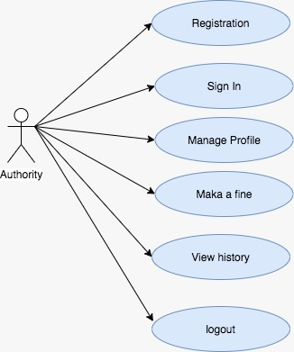

figure 19: Use case Diagram for Authority

**Use Case Scenarios**

|  |  |
| --- | --- |
| UC-01 | Admin Login |
| UC-02 | Admin Add Authority |
| UC-03 | Admin View Authority |
| UC-04 | Admin Edit Authority |
| UC-05 | Admin Verify Car Details |
| UC-06 | Admin view pending fines |
| UC-07 | Admin view paid fines |
| UC-08 | Admin view complaints |
| UC-09 | Admin view due transactions |
| UC-10 | Authority Registration |
| UC-11 | Authority Login |
| UC-12 | Manage Authority Profile |
| UC-13 | Authority add fines |
| UC-14 | Authority View history |
| UC-15 | User Registration |
| UC-16 | User Login |
| UC-17 | Manage User Profile |
| UC-18 | Manage User cars |
| UC-19 | User pay fines |
| UC-20 | View challans |
| UC-21 | User fines History |
| UC-22 | User complaints |
| UC-23 | Logout |

Table 1. Listing of Use Cases

**UC-1– Admin Login**

|  |  |
| --- | --- |
| System: | Smart Towing Application |
| Identifier: | UC-1 |
| Author(s): | Admin |
| Version: | None |
| Name: | Admin Login |
| Pre- Condition(s): | The Admin is registered and has an account on Smart Towing Application |
| Post- Condition(s): | The Admin is directed to the homepage of Application Which is specific to the Admin. |
| Trigger: | The Admin has clicked on the Admin Login button. |
| Normal Flow: | * Admin clicks on the Login button. * Admin enters the user name and the password in the form. * Admin is directed to the homepage specific to the admin. |
| Alternate Flow: | None |
| Exceptional Flow(s): | 1.The user enters wrong password or username.  2. The system will prompt the message “Wrong User name or password, Try again” on the phone screen. |
| Related Actor(s): | **Primary**-Registered Admin |
| Related Use Case(s): | None |

UC-1: Admin Login

**UC-2– Admin Add Authority**

|  |  |
| --- | --- |
| System: | Smart Towing Application |
| Identifier: | UC-2 |
| Author(s): | Admin |
| Version: | None |
| Name: | Admin Add Authority |
| Pre- Condition(s): | The Admin should be logged in Smart Towing Application |
| Post- Condition(s): | The Admin will add the authority |
| Trigger: | The Admin has clicked on the Add authority button. |
| Normal Flow: | * Admin clicks on the Add authority button. * Admin enters the Name, Email ID, Phone Number, Password, and Photo of the particular person * Admin is directed to the homepage specific to the admin. |
| Alternate Flow: | None |
| Exceptional Flow(s): | 1.The user enters Existing details.  2. The system will prompt the message “User already exists” on the phone screen. |
| Related Actor(s): | **Primary**-Registered Admin |
| Related Use Case(s): | None |

UC-2: Admin Add Authority

**UC-3– Admin View Authority**

|  |  |
| --- | --- |
| System: | Smart Towing Application |
| Identifier: | UC-3 |
| Author(s): | Admin |
| Version: | None |
| Name: | Admin View Authority |
| Pre- Condition(s): | The Admin should be logged in Smart Towing Application |
| Post- Condition(s): | The Admin will view the authority |
| Trigger: | The Admin has clicked on the View authority button. |
| Normal Flow: | * Admin clicks on the View authority button. * Admin can see the total number of authorities working |
| Alternate Flow: | None |
| Exceptional Flow(s): | none |
| Related Actor(s): | **Primary**-Registered Admin |
| Related Use Case(s): | None |

UC-3: Admin View Authority

**UC-4 Admin Edit Authority**

|  |  |
| --- | --- |
| System: | Smart Towing Application |
| Identifier: | UC-4 |
| Author(s): | Admin |
| Version: | None |
| Name: | Admin Edit Authority |
| Pre- Condition(s): | The Admin should be logged in Smart Towing Application |
| Post- Condition(s): | The Admin can edit/delete the details of the authority |
| Trigger: | The Admin has clicked on the Edit authority button. |
| Normal Flow: | * Admin clicks on the Edit authority button. * Admin can edit or delete the details of the authority * Admin will redirect to the home page after editing the details |
| Alternate Flow: | None |
| Exceptional Flow(s): | 1. **T**he admin will update the details of the authority  2. The system will prompt the message “details updated successfully” on the phone screen. |
| Related Actor(s): | **Primary**-Registered Admin |
| Related Use Case(s): | None |

UC-4: Admin Edit Authority

**UC-5– Admin Verify Car Details**

|  |  |
| --- | --- |
| System: | Smart Towing Application |
| Identifier: | UC-5 |
| Author(s): | Admin |
| Version: | None |
| Name: | Admin Verify car details |
| Pre- Condition(s): | The Admin should be logged in Smart Towing Application |
| Post- Condition(s): | The Admin can verify the car details |
| Trigger: | The Admin has clicked on the verify car button. |
| Normal Flow: | * Admin clicks on the verify carsbutton. * Admin can view the details of the confined car |
| Alternate Flow: | None |
| Exceptional Flow(s): | none |
| Related Actor(s): | **Primary**-Registered Admin |
| Related Use Case(s): | None |

UC-5: Admin verify car details

**UC-6– Admin view pending fines**

|  |  |
| --- | --- |
| System: | Smart Towing Application |
| Identifier: | UC-6 |
| Author(s): | Admin |
| Version: | None |
| Name: | Admin view pending fines |
| Pre- Condition(s): | The Admin should be logged in Smart Towing Application |
| Post- Condition(s): | The Admin can view the pending fines of the users |
| Trigger: | The Admin has clicked on the pending fines button. |
| Normal Flow: | * Admin clicks on the pending fines button. * Admin can view the details pending fines of the users |
| Alternate Flow: | None |
| Exceptional Flow(s): | none |
| Related Actor(s): | **Primary**-Registered Admin |
| Related Use Case(s): | None |

UC-6: Admin view pending fines

**UC-7– Admin view paid fines**

|  |  |
| --- | --- |
| System: | Smart Towing Application |
| Identifier: | UC-7 |
| Author(s): | Admin |
| Version: | None |
| Name: | Admin view paid fines |
| Pre- Condition(s): | The Admin should be logged in Smart Towing Application |
| Post- Condition(s): | The Admin can view the paid fines of the users |
| Trigger: | The Admin has clicked on the paid fines button. |
| Normal Flow: | * Admin clicks on the paid fines button. * Admin can view the details of the fines paid by the users |
| Alternate Flow: | None |
| Exceptional Flow(s): | none |
| Related Actor(s): | **Primary**-Registered Admin |
| Related Use Case(s): | None |

UC-7: Admin view paid fines

**UC-8– Admin view complaints**

|  |  |
| --- | --- |
| System: | Smart Towing Application |
| Identifier: | UC-8 |
| Author(s): | Admin |
| Version: | None |
| Name: | Admin view complaints |
| Pre- Condition(s): | The Admin should be logged in Smart Towing Application |
| Post- Condition(s): | The Admin can view the complaints files against the users |
| Trigger: | The Admin has clicked on the complaints button. |
| Normal Flow: | * Admin clicks on the complaintsbutton. * Admin can view the complaints made against the users |
| Alternate Flow: | None |
| Exceptional Flow(s): | none |
| Related Actor(s): | **Primary**-Registered Admin |
| Related Use Case(s): | None |

UC-8: Admin view complaints

**UC-9– Admin view due transactions**

|  |  |
| --- | --- |
| System: | Smart Towing Application |
| Identifier: | UC-9 |
| Author(s): | Admin |
| Version: | None |
| Name: | Admin view due transactions |
| Pre- Condition(s): | The Admin should be logged in Smart Towing Application |
| Post- Condition(s): | The Admin can view the due transactions made by the users |
| Trigger: | The Admin has clicked on the transactions button. |
| Normal Flow: | * Admin clicks on the transactionsbutton. * Admin can view the due transactions made by the users |
| Alternate Flow: | None |
| Exceptional Flow(s): | none |
| Related Actor(s): | **Primary**-Registered Admin |
| Related Use Case(s): | None |

UC-9: Admin view due transactions

**UC-10: Authority Registration**

|  |  |
| --- | --- |
| System: | Smart Towing Application |
| Identifier: | UC-10 |
| Author(s): | Authorities |
| Version: | None |
| Name: | Authorities sign up |
| Pre- Condition(s): | The user is non-registered and does not have an account on Smart Towing Application |
| Post- Condition(s): | The user is directed to the Home Page of the Application. |
| Trigger: | The user has clicked on the Sign-Up button. |
| Normal Flow: | * User clicks on the Sign-Up button to create the userprofile. * User enters the details in the form and sets up the user name and password. * Then after registration user will be redirected to the Home Page. |
| Alternate Flow: | None |
| Exceptional Flow(s): | **Exception:** There is an occurrence of internet connection failure.  1. The system will prompt the message “No Internet Connection, try Again” on the phone Screen. |
| Related Actor(s): | **Primary**-Non-Registered User  **Secondary**-None |
| Related Use Case(s): | None |

UC-10: Authority signup

**UC-11: Authority Login**

|  |  |
| --- | --- |
| System: | Smart Towing Application |
| Identifier: | UC-11 |
| Author(s): | Authority |
| Version: | None |
| Name: | Login |
| Pre- Condition(s): | The user is registered and has an account on Smart Towing Application |
| Post- Condition(s): | The user is directed to the homepage of Application Which is specific to the user. |
| Trigger: | The user has clicked on the Login button. |
| Normal Flow: | * User clicks on the Loginbutton. * User enters the user name and the password in theform. * User is directed to the homepage specific to theuser. |
| Alternate Flow: | * User clicks on “forget password”. * User enters the email used forregistration. * Email to change password is send to the user’s emailaddress. * User changes the password and confirms thechanges. * User is directed to the Login page. * User enters the user name and the password in theform. * User is directed to the homepage specific to theuser. |
| Exceptional Flow(s): | **Exception:** The user enters wrong password orusername.  2. The system will prompt the message “Wrong User name or password, Try again” on the phone screen. |
| Related Actor(s): | **Primary**-Registered User  **Secondary**-None |
| Related Use Case(s): | None |

UC-11: Authority Login

**UC-12 – Manage Authority Profile**

|  |  |
| --- | --- |
| System: | Smart Towing Application |
| Identifier: | UC-12 |
| Author(s): | Authority |
| Version: | None |
| Name: | Manage user’s Profile |
| Pre- Condition(s): | * The user is registered and must have an account on Smart Towing Application. * User Logs in with correct username and password |
| Post- Condition(s): | The user is directed to Home Page where he/she can check reports/stats |
| Trigger: | The user has to click my profile button |
| Normal Flow: | * User will redirect to the profile page where he/she can manage their profile by modifying/delete data |
| Alternate Flow: | * Users can check their profile whether their details have been updated or not |
| Exceptional Flow(s): | **Exception:** There is an occurrence of internet connection failure.  1. The system will prompt the message “No Internet Connection, try Again” on the phone Screen. |
| Related Actor(s): | **Primary**-Registered User |
| Related Use Case(s): | None |

UC-12: Managing Authority profile

**UC-13 –Authority add fines**

|  |  |
| --- | --- |
| System: | Smart Towing Application |
| Identifier: | UC-13 |
| Author(s): | Authority |
| Version: | None |
| Name: | Authority Add fines |
| Pre- Condition(s): | * The user is registered and must have an account on Smart Towing Application. * User Logs in with correct username and password |
| Post- Condition(s): | The user is directed to Home Page where he/she can check reports/stats |
| Trigger: | The user has to click my add fines button |
| Normal Flow: | * User will redirect to the add fines pages * User will enter the details like title, description, fee, number plate, and pic of the scene |
| Alternate Flow: | none |
| Exceptional Flow(s): | **Exception:** There is an occurrence of internet connection failure.  1. The system will prompt the message “No Internet Connection, try Again” on the phone Screen. |
| Related Actor(s): | **Primary**-Registered User |
| Related Use Case(s): | None |

UC-13: Authority add fines

**UC-14 –Authority View history**

|  |  |
| --- | --- |
| System: | Smart Towing Application |
| Identifier: | UC-14 |
| Author(s): | Authority |
| Version: | None |
| Name: | Authority view history |
| Pre- Condition(s): | * The user is registered and must have an account on Smart Towing Application. * User Logs in with correct username and password |
| Post- Condition(s): | The user is directed to Home Page |
| Trigger: | The user has to click historybutton |
| Normal Flow: | * User will redirect to the history pages * User will check the details of the fines made by him |
| Alternate Flow: | none |
| Exceptional Flow(s): | **Exception:** There is an occurrence of internet connection failure.  1. The system will prompt the message “No Internet Connection, try Again” on the phone Screen. |
| Related Actor(s): | **Primary**-Registered User |
| Related Use Case(s): | None |

UC-14: Authority history

**UC-15: User Registration**

|  |  |
| --- | --- |
| System: | Smart Towing Application |
| Identifier: | UC-15 |
| Author(s): | User |
| Version: | None |
| Name: | User sign up |
| Pre- Condition(s): | The user is non-registered and does not have an account on Smart Towing Application |
| Post- Condition(s): | The user is directed to the Home Page of the Application. |
| Trigger: | The user has clicked on the Sign-Up button. |
| Normal Flow: | * User clicks on the Sign-Up button to create the userprofile. * User enters the details in the form and sets up the user name and password. * Then after registration user will be redirected to the Home Page. |
| Alternate Flow: | None |
| Exceptional Flow(s): | **Exception:** There is an occurrence of internet connection failure.  1. The system will prompt the message “No Internet Connection, try Again” on the phone Screen. |
| Related Actor(s): | **Primary**-Non-Registered User  **Secondary**-None |
| Related Use Case(s): | None |

UC-15: User registration

**UC-16: User Login**

|  |  |
| --- | --- |
| System: | Smart Towing Application |
| Identifier: | UC-16 |
| Author(s): | User |
| Version: | None |
| Name: | Login |
| Pre- Condition(s): | The user is registered and has an account on Smart Towing Application |
| Post- Condition(s): | The user is directed to the homepage of Application Which is specific to the user. |
| Trigger: | The user has clicked on the Login button. |
| Normal Flow: | * User clicks on the Loginbutton. * User enters the user name and the password in theform. * User is directed to the homepage specific to theuser. |
| Alternate Flow: | * User clicks on “forget password”. * User enters the email used forregistration. * Email to change password is send to the user’s emailaddress. * User changes the password and confirms thechanges. * User is directed to the Login page. * User enters the user name and the password in theform. * User is directed to the homepage specific to theuser. |
| Exceptional Flow(s): | **Exception:** The user enters wrong password orusername.  2. The system will prompt the message “Wrong User name or password, Try again” on the phone screen. |
| Related Actor(s): | **Primary**-Registered User  **Secondary**-None |
| Related Use Case(s): | None |

UC-16: User Login

**UC-17 – Manage User Profile**

|  |  |
| --- | --- |
| System: | Smart Towing Application |
| Identifier: | UC-17 |
| Author(s): | User |
| Version: | None |
| Name: | Manage user’s Profile |
| Pre- Condition(s): | * The user is registered and must have an account on Smart Towing Application. * User Logs in with correct username and password |
| Post- Condition(s): | The user is directed to Home Page |
| Trigger: | The user has to click my profile button |
| Normal Flow: | * User will redirect to the profile page where he/she can manage their profile by modifying/delete data |
| Alternate Flow: | * Users can check their profile whether their details have been updated or not |
| Exceptional Flow(s): | **Exception:** There is an occurrence of internet connection failure.  1. The system will prompt the message “No Internet Connection, try Again” on the phone Screen. |
| Related Actor(s): | **Primary**-Registered User |
| Related Use Case(s): | None |

UC-17: Managing User profile

**UC-18 – Manage User cars**

|  |  |
| --- | --- |
| System: | Smart Towing Application |
| Identifier: | UC-18 |
| Author(s): | User |
| Version: | None |
| Name: | Manage user’s cats |
| Pre- Condition(s): | * The user is registered and must have an account on Smart Towing Application. * User Logs in with correct username and password |
| Post- Condition(s): | The user is directed to Home Page |
| Trigger: | The user has to click manage cars button |
| Normal Flow: | * User will redirect to the manage cars page * User will select the cars to pay fine and to check challans |
| Alternate Flow: | none |
| Exceptional Flow(s): | **Exception:** There is an occurrence of internet connection failure.  1. The system will prompt the message “No Internet Connection, try Again” on the phone Screen. |
| Related Actor(s): | **Primary**-Registered User |
| Related Use Case(s): | None |

UC-18: Managing User cars

**UC-19 – User pay fines**

|  |  |
| --- | --- |
| System: | Smart Towing Application |
| Identifier: | UC-19 |
| Author(s): | User |
| Version: | None |
| Name: | User pay fines |
| Pre- Condition(s): | * The user is registered and must have an account on Smart Towing Application. * User Logs in with correct username and password |
| Post- Condition(s): | The user is directed to Home Page |
| Trigger: | The user has to click on the pay fines button |
| Normal Flow: | * User will redirect to the Challans page so that they can pay the fine |
| Alternate Flow: | none |
| Exceptional Flow(s): | **Exception:** There is an occurrence of internet connection failure.  1. The system will prompt the message “No Internet Connection, try Again” on the phone Screen. |
| Related Actor(s): | **Primary**-Registered User |
| Related Use Case(s): | None |

UC-19: User pay fines

**UC-20 – View challans**

|  |  |
| --- | --- |
| System: | Smart Towing Application |
| Identifier: | UC-20 |
| Author(s): | User |
| Version: | None |
| Name: | View challans |
| Pre- Condition(s): | * The user is registered and must have an account on Smart Towing Application. * User Logs in with correct username and password |
| Post- Condition(s): | The user is directed to Home Page |
| Trigger: | The user has to click challans button |
| Normal Flow: | * User will redirect to the Challans page where users can check the challans, they have on their car |
| Alternate Flow: | none |
| Exceptional Flow(s): | **Exception:** There is an occurrence of internet connection failure.  1. The system will prompt the message “No Internet Connection, try Again” on the phone Screen. |
| Related Actor(s): | **Primary**-Registered User |
| Related Use Case(s): | None |

UC-20: View challans

**UC-21 – User fines History**

|  |  |
| --- | --- |
| System: | Smart Towing Application |
| Identifier: | UC-21 |
| Author(s): | User |
| Version: | None |
| Name: | User fineshistory |
| Pre- Condition(s): | * The user is registered and must have an account on Smart Towing Application. * User Logs in with correct username and password |
| Post- Condition(s): | The user is directed to Home Page |
| Trigger: | The user has to click on the History button |
| Normal Flow: | * User will redirect to the history page where he can check his fine and transaction details |
| Alternate Flow: | none |
| Exceptional Flow(s): | **Exception:** There is an occurrence of internet connection failure.  1. The system will prompt the message “No Internet Connection, try Again” on the phone Screen. |
| Related Actor(s): | **Primary**-Registered User |
| Related Use Case(s): | None |

UC-21: User fines history

**UC-22 – User complaints**

|  |  |
| --- | --- |
| System: | Smart Towing Application |
| Identifier: | UC-22 |
| Author(s): | User |
| Version: | None |
| Name: | User complaints |
| Pre- Condition(s): | * The user is registered and must have an account on Smart Towing Application. * User Logs in with correct username and password |
| Post- Condition(s): | The user is directed to Home Page |
| Trigger: | The user has to click on the complaints button |
| Normal Flow: | * User will redirect to the complaints page * User will fill the form for making an complaint * User clicks on the submit button |
| Alternate Flow: | none |
| Exceptional Flow(s): | **Exception:** There is an occurrence of internet connection failure.  1. The system will prompt the message “No Internet Connection, try Again” on the phone Screen. |
| Related Actor(s): | **Primary**-Registered User |
| Related Use Case(s): | None |

UC-22: User complaints

**UC-23– Logout**

|  |  |
| --- | --- |
| System: | Smart Towing Application |
| Identifier: | UC-8 |
| Author(s): | Team 2 |
| Version: | None |
| Name: | Logout |
| Pre- Condition(s): | The user should be logged in Smart Towing Application |
| Post- Condition(s): | The user is directed to the Login page |
| Trigger: | The user has clicked on the Logout button. |
| Normal Flow: | * User will click on the logout button if the user to wishes to change device or to login into other account |
| Alternate Flow: | None |
| Exceptional Flow(s): | None |
| Related Actor(s): | **Primary**-Registered User |
| Related Use Case(s): | None |

UC-23: Logout

**5.2 Sequence Diagrams**

A sequence diagram shows object interactions arranged in time sequence. It depicts the objects and classes involved in the scenario and the sequence of messages exchanged between the objects needed to carry out the functionality of the scenario.

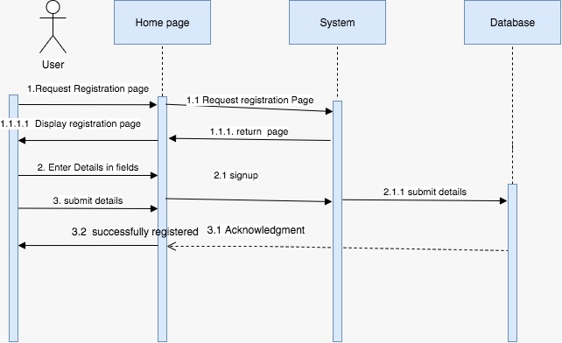

figure 20: Registration Sequence Diagram for User

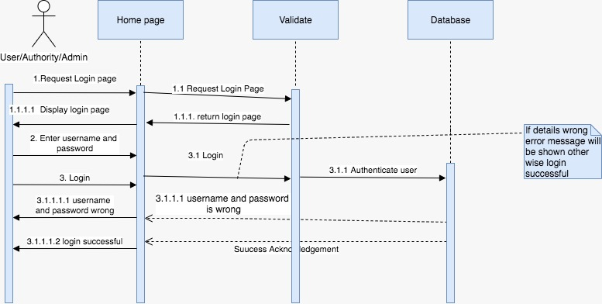

figure 21: Login Sequence Diagram for User/Authority/Admin

**Sequence Diagram for User Actions**

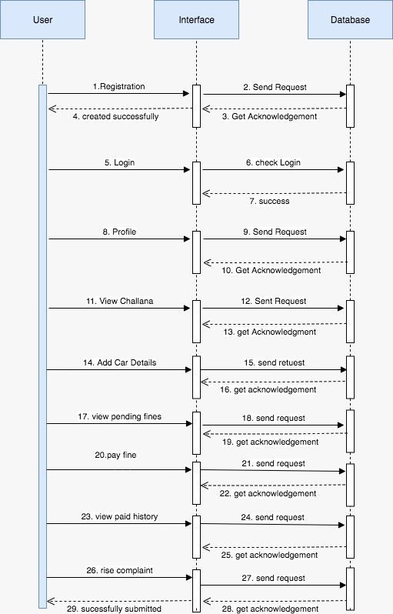

figure 22: Sequence Diagram for User Actions

**Sequence Diagram for Authority Actions**

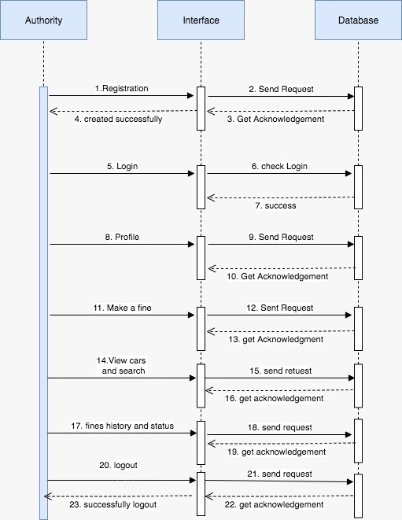

figure 23: Sequence Diagram for Authority Actions

**6.3 Class Diagrams**

A class model is the most fundamental model for a system to be done. This is because it describes what is changing within a system. This can be simply viewed with a Design Class Diagram as the class model mainly specifies data structures and operations that the behavioral and functional models operate on. This leads me to the key feature (subject) of a class model – Classes Elements of class model include:

* Identity
* Relationships
* Attributes
* Methods

**CHAPTER 7**

# DATABASE DESCRIPTION

## **7.1 MySQL**

*SQLite* is afree Source database that is available to everyone with no cost. SQL database is a relational database. The data ae stored in rows and columns and this have feautes like SQL syntax and prepared statements. The database needsmall memory at runtime (approx. 250 Kbyte).

SQL supports the following data types:

TEXT (similar to String in Java)

INTEGER (similar to long in Java)

REAL (similar to double in Java).

Every row in the database has to be handled carefully while inserting the data. If the inserting data is not stable or according to the CREATED database then the data will not be inserted, there will be a NULL value. It is mandatory to remember the structure of the database before we try to insert the values into the created database.

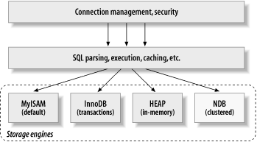

Fig. 24. MYSQL Architecture

In order to create database we just need to call this method OPEN or CREATE Database with your database name and mode as a parameter.

**7.2 CREATING TABLES**

Once database is created, it’s time to create some tables in the database. The CREATE TABLE statement creates the database.

A database is an organized collection of data, generally stored and accessed electronically from a computer system. These model data as rows and columns in a series of tables, and the vast majority use SQL for writing and querying data.

**Data Dictionaries**

|  |  |  |  |  |  |
| --- | --- | --- | --- | --- | --- |
| **tb_sts_user_registration** | | | | | |
|  | **Column Name** | **Data Type** | **Length** | **Nullable** | **Description** |
| 1 | id | INT | 11 | N | Contains user id |
| 2 | first_name | VARCHAR | 50 | N | First name for user login |
| 3 | last_name | VARCHAR | 50 | N | Last name for user login |
| 4 | phonenumber | VARCHAR | 20 | N | Phone number |
| 5 | emaiid | VARCHAR | 50 | N | E-mail of user |
| 6 | pwd | VARCHAR | 50 | N | password type |
| 7 | fcm_token | TEXT |  | N | fcm for user login |
| 8 | photo | VARCHAR | 100 | N | Contains  type of user/authority |

|  |  |  |  |  |  |
| --- | --- | --- | --- | --- | --- |
| **tb_sts_admin_registration** | | | | | |
|  | **Column Name** | **Data Type** | **Length** | **Nullable** | **Description** |
| 1 | id | INT | 11 | N | Contains admin id |
| 2 | name | VARCHAR | 50 | N | name for admin |
| 3 | emailid | VARCHAR | 50 | N | Email for admin |
| 4 | phno | VARCHAR | 50 | N | Phone number |
| 5 | username | VARCHAR | 50 | N | username |
| 6 | pwd | VARCHAR | 50 | N | password |

|  |  |  |  |  |  |
| --- | --- | --- | --- | --- | --- |
| **tb_sts_authority_registration** | | | | | |
|  | **Column Name** | **Data Type** | **Length** | **Nullable** | **Description** |
| 1 | id | INT | 11 | N | Contains authority id |
| 2 | name | VARCHAR | 50 | N | First name for authority login |
| 3 | emailid | VARCHAR | 50 | N | Email for authority login |
| 4 | phno | VARCHAR | 50 | N | Phone number |
| 5 | pwd | VARCHAR | 50 | N | Password of authority |
| 6 | photo | VARCHAR | 100 | N | Authority photo |

|  |  |  |  |  |  |
| --- | --- | --- | --- | --- | --- |
| **tb_sts_station_details** | | | | | |
|  | **Column Name** | **Data Type** | **Length** | **Nullable** | **Description** |
| 1 | id | INT | 11 | N | Contains Location id |
| 2 | station_name | VARCHAR | 50 | N | Station name |
| 3 | lat | VARCHAR | 50 | N | Latitude |
| 4 | lng | VARCHAR | 50 | N | Longitude |

|  |  |  |  |  |  |
| --- | --- | --- | --- | --- | --- |
| **tb_car_details** | | | | | |
|  | **Column Name** | **Data Type** | **Length** | **Nullable** | **Description** |
| 1 | cid | INT | 11 | N | Contains car id |
| 2 | make | VARCHAR | 50 | N | Car make |
| 3 | model | VARCHAR | 50 | N | Car model |
| 4 | color | VARCHAR | 50 | N | Car color |
| 5 | number_plate | VARCHAR | 50 | N | Car number plate |
| 6 | email | VARCHAR | 100 | N | User email |
| 7 | image | VARCHAR | 100 | N | Car image |
| 8 | c_status | VARCHAR | 50 | N | Contains  car status |

|  |  |  |  |  |  |
| --- | --- | --- | --- | --- | --- |
| **tb_sts_user_fines** | | | | | |
|  | **Column Name** | **Data Type** | **Length** | **Nullable** | **Description** |
| 1 | id | INT | 11 | N | fine id |
| 2 | title | VARCHAR | 50 | N | fine title |
| 3 | description | VARCHAR | 100 | N | Fine description |
| 4 | fee | VARCHAR | 20 | N | Fine amount |
| 5 | number_plate | VARCHAR | 20 | N | Car number plate |
| 6 | status | VARCHAR | 10 | N | Car status |
| 7 | sname | VARCHAR | 50 | N | Station name |
| 8 | lat | VARCHAR | 50 | N | Latitude |
| 9 | lng | VARCHAR | 50 | N | Longitude |
| 10 | pic | VARCHAR | 100 | N | Reason image |
| 11 | aname | VARCHAR | 50 | N | Authority email |
| 12 | cid | INT | 11 |  | Car id |

|  |  |  |  |  |  |
| --- | --- | --- | --- | --- | --- |
| **td_complaints** | | | | | |
|  | **Column Name** | **Data Type** | **Length** | **Nullable** | **Description** |
| 1 | id | INT | 11 | N | Contains complaints id |
| 2 | title | VARCHAR | 50 | N | Complaint title |
| 3 | problem | VARCHAR | 500 | N | Complaint problem description |
| 4 | email | VARCHAR | 100 | N | User email |

**7.3 Database Script**

drop database if exists vehicle_tracking;

create database vehicle_tracking;

use vehicle_tracking;

**-- Table structure for table `tb_car_details` --**

CREATE TABLE `tb_car_details`

 (

 `cid` int(11) NOT NULL, `make` varchar(50) NOT NULL, `model` varchar(50) NOT NULL, `color` varchar(50) NOT NULL, `number_plate` varchar(50) NOT NULL, `email` varchar(100) NOT NULL, `image` varchar(100) NOT NULL, `c_status` varchar(50) NOT NULL

) ENGINE=InnoDB DEFAULT CHARSET=latin1;

**-- Table structure for table `tb_sts_admin_registration` --**

CREATE TABLE `tb_sts_admin_registration`

(

 `id` int(11) NOT NULL, `name` varchar(50) NOT NULL, `emailid` varchar(50) NOT NULL, `phno` varchar(50) NOT NULL, `username` varchar(50) NOT NULL, `pwd` varchar(50) NOT NULL

) ENGINE=InnoDB DEFAULT CHARSET=utf8;

**-- Table structure for table `tb_sts_authority_registration` --**

CREATE TABLE `tb_sts_authority_registration`

 (

`id` int(11) NOT NULL, `name` varchar(50) NOT NULL, `emailid` varchar(50) NOT NULL, `phno` varchar(50) NOT NULL, `pwd` varchar(50) NOT NULL, `photo` varchar(100) NOT NULL

) ENGINE=InnoDB DEFAULT CHARSET=utf8;

**-- Table structure for table `tb_sts_station_details` --**

CREATE TABLE `tb_sts_station_details`

 (

`id` int(11) NOT NULL, `station_name` varchar(50) NOT NULL, `lat` varchar(50) NOT NULL, `lng` varchar(50) NOT NULL

) ENGINE=MyISAM DEFAULT CHARSET=latin1;

**-- Table structure for table `tb_sts_user_fines` --**

CREATE TABLE `tb_sts_user_fines`

(

 `id` int(11) NOT NULL, `title` varchar(50) NOT NULL, `description` varchar(100) NOT NULL, `fee` varchar(20) NOT NULL, `number_plate` varchar(20) NOT NULL, `status` varchar(10) NOT NULL DEFAULT 'pending', `sname` varchar(50) NOT NULL, `lat` varchar(50) NOT NULL, `lng` varchar(50) NOT NULL, `pic` varchar(100) NOT NULL, `aname` varchar(50) NOT NULL, `cid` int(11) NOT NULL

) ENGINE=InnoDB DEFAULT CHARSET=latin1;

**-- Table structure for table `tb_sts_user_registration` --**

CREATE TABLE `tb_sts_user_registration`

(

`id` int(11) NOT NULL, `first_name` varchar(50) NOT NULL, `last_name` varchar(50) NOT NULL, `phonenumber` varchar(20) NOT NULL, `emailid` varchar(50) NOT NULL, `pwd` varchar(50) NOT NULL, `fcm_token` text NOT NULL, `photo` varchar(100) NOT NULL

) ENGINE=InnoDB DEFAULT CHARSET=utf8;

**-- Table structure for table `td_complaints` --**

CREATE TABLE `td_complaints`

(

 `Id` int(11) NOT NULL, `title` varchar(50) NOT NULL, `problem` varchar(500) NOT NULL, `email` varchar(100) NOT NULL

) ENGINE=MyISAM DEFAULT CHARSET=latin1;

**7.4 Database Schema**

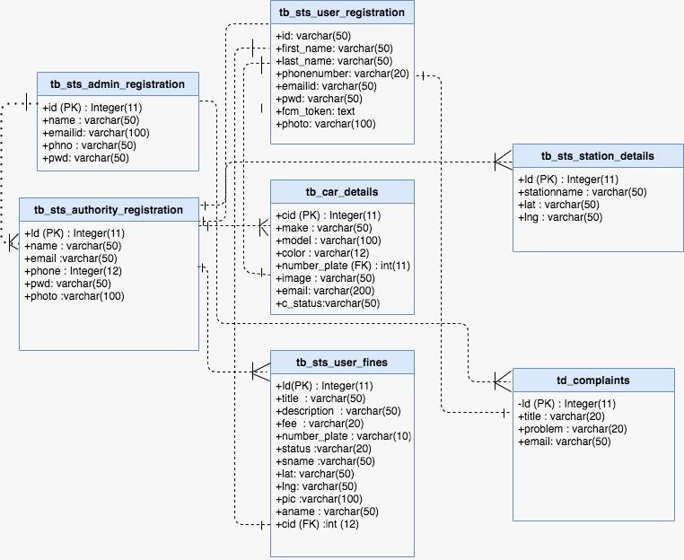

Fig. 25. Database Schema

**CHAPTER 8**

# conclusion and Future work

7.1 CONCLUSION

The aim of this project was to create AI powered smart towing management app which will house our proposed machine leaning module for detecting numberplates. During the period of this project, I learned a lot of new things that I didn't try before. The most difficult part I faced was to merge the Numberplate detection module to the android app. At first, I thought of using TensorFlow lite which is used in android devices or any low computation powered devices, but it was very difficult to convert a TensorFlow model into the Tflite model. Then I came up with the idea of using the TensorFlow Model to deploy it on a server and make communication with it using retrofit by sending the response and getting the recognized numberplate in text form as response. This has opened many opportunities to incorporate many ML module to the interface or other project easily.

The License Plate detection module which was proposed and developed is successfully detect any kind of number plate from any regions. The performance of the model indicates to a high detection level that our system can detect and return the result of the information to users both locally and with the app on the cloud. This project solves several social and technical aspects and issues regarding vehicle management.

7.2 FUTURE WORK

We have many more things that can be done in the future to make both our app and the module more effective and powerful than ever. I will keep myself in perusing those goals. Some of the future aspects of this project can be.

* The inclusion of video steam so that we can capture the numberplate directly from the video and also can save critical clips from it.
* We can further include the parking management features in the app and also enable the feature so that the app can also provide support for many embedded devices like smart camera.

# REFERENCES

1. https://www.peerbits.com/blog/all-about-app-architecture-for- efficient-mobile-app-development.html
2. https://searchmobilecomputing.techtarget.com/definition/mobile- UI-mobile-user-interface
3. https://developer.android.com/
4. https://www.tutlane.com/tutorial/android/android-ui-controls-textview-edittext-radio-button-checkbox
5. https://developer.android.com/guide/components/activities/process-lifecycle
6. software:<https://developer.android.com/guide/index.html>
7. php:<https://www.developer.com/ws/android/programming/Build-Your-First-PHP-for-Android-Application-3904261.html>
8. My sql:<http://www.vogella.com/tutorials/AndroidSQLite/article.html>
9. Introduction to android 4.4:<https://developer.android.com/about/versions/android-4.4.html>
10. Intent filter:<https://developer.android.com/guide/topics/manifest/intent-filter-element.html>
11. https://www.leewardpro.com/articles/licplatefonts/licplate-fonts-nam.html
12. starting activities:<http://www.vogella.com/tutorials/AndroidIntent/article.html>
13. what are intents:<http://www.vogella.com/tutorials/AndroidIntent/article.html>
14. On destroy:<https://stackoverflow.com/questions/13927269/use-of-ondestroy-in-android>
15. On create:<https://stackoverflow.com/questions/19538976/what-is-a-oncreate-method-in-android>
16. Activity life cycle:<https://developer.android.com/guide/components/activities/activity-lifecycle.html>
17. Android emulator:<https://stackoverflow.com/tags/android-emulator/info>
18. Essential command line tools:<https://developer.android.com/studio/command-line/index.html>
19. Publishing:<https://developer.android.com/studio/publish/index.html>
20. uptodevelopement:<https://hheell.files.wordpress.com/2017/06/introductiontoandroidapplicationdevelopment4thedition.pdf>
21. <http://www.techotopia.com/index.php/An_Overview_of_the_Android_Architecture>
22. Debugging and testing:<https://www.d.umn.edu/~gshute/softeng/testing.html>
23. [www.android.com](http://www.android.com)
24. [www.developer.android.com](http://www.developer.android.com)
25. [www.vogella.com](http://www.vogella.com)
26. [www.developers.google.com](http://www.developers.google.com)
27. [www.sqlite.org](http://www.sqlite.org)
28. Android Developer - <https://developer.android.com/index.html>
29. MySQL - <https://www.mysql.com/>
30. Stack Overflow - <https://stackoverflow.com/>-
31. PHP - <http://php.net/manual/en/index.php>
32. <https://developer.android.com/design/material/index.html>
33. <http://www.java2s.com/Code/Android/CatalogAndroid.html>
34. <https://www.javatpoint.com/android-option-menu-example>
35. <https://www.androidhive.info/2015/09/android-material-design-snackbar-example/>
36. <https://www.survivingwithandroid.com/2013/03/android-fragment-tutorial-webview-example.html>
37. CVPR 2014 TUTORIAL ON DEEP LEARNING FOR VISION.[online]. <https://sites.google.com/site/deeplearningcvpr2014/>
38. “Open Source — openalpr 2.5.103 documentation.” [Online].Available:[http://doc.openalpr.com/opensource .html.](http://doc.openalpr.com/opensource%20.html.)
39. Baoming Shan "Vehicle License Plate Recognition Based on Text-line Construction and Multilevel RBF Neural Network" Journal of computer science Vol. no. 6 pp. 246-253 February 2011.
40. Chetan Sharma and Amandeep Kaur "Indian Vehicle License plate Extraction and Segmentation" International Journal of Computer Science and Communication Vol. No.2, pp. 593 599, July-December 2017.
41. Comparison of various edge detection filters for ANPR” Lubna; M. F. Khan; N. Mufti 2018
42. M. Rasooli, S. Ghofrani, and E. Fatemizadeh, "Farsi License Plate Detection based on Element Analysis and Characters Recognition," International Journal of Signal Processing, Image Processing and Pattern Recognition, vol. 4, no. 1, pp. 65-80, 2011.
43. An automated vehicle parking monitoring and management system using ANPR cameras Mohammed Y Aalsalem;Wazir Zada Khan;Khalid Mohammed Dhabbah 2015 17th International Conference on Advanced Communication Technology (ICACT)
44. Automatic Number Plate Recognition System (ANPR): A Survey 2017 Chirag Patel,Dipti Shaha
45. The automated parking fee calculation using license plate recognition system Worawut Yimyam;Mahasak Ketcham 2017 International Conference on Digital Arts, Media and Technology (ICDAMT)
46. <https://texaslawhelp.org/article/towed-vehicles>
47. <https://www.lawyersandsettlements.com/lawsuit/socal-towing.html>
48. An Efficient Character Recognition Technique Using K-Nearest Neighbor Classifier November 2018 DOI: 10.14419/ijet.v7i4.18952 Nawaf Hazim Mohanad Hazim Nsaif Al- Faiz Aboalmaaly Mohammed Faiz Aboalmaaly

# APPENDIX

**Home Screen/Login Screen**: Once user opens the application icon, after splash screen, user will be on Home screen shown below. From this screen, user needs to Login to be taken to the user dashboard and if admin login in, then admin would be taking to the Admin Dashboard. If it is a new user, he/she can register to the application by giving the necessary information.

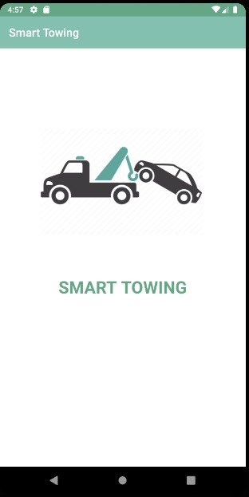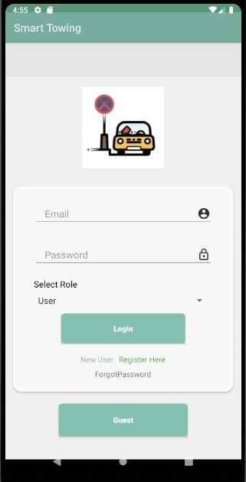

Screen 1: Login Screen

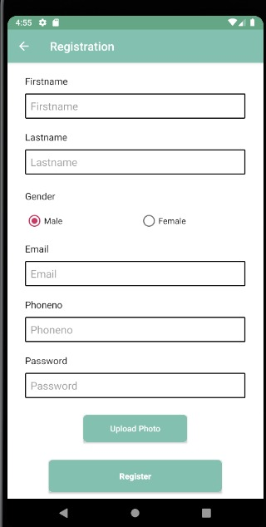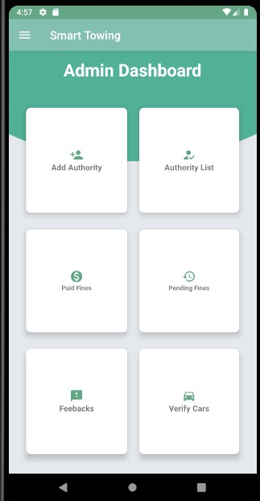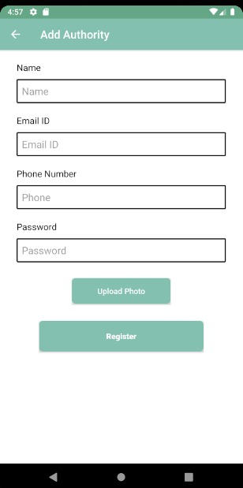

Screen 2: Registration Screen 3: Admin Dashboard Screen 4: Manage Profile

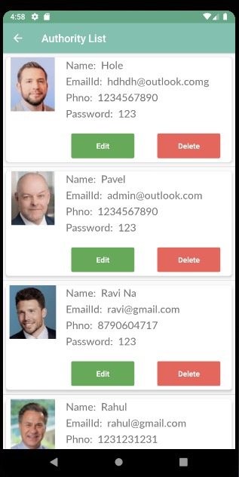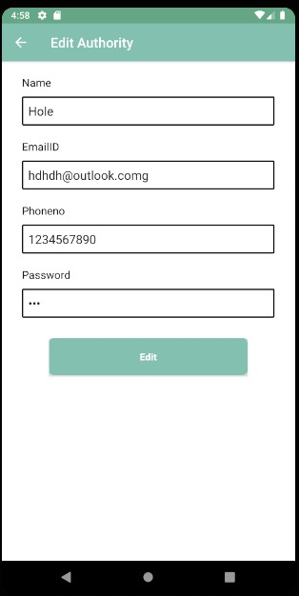

Screen 5: Authority List Screen 6: Edit Activity

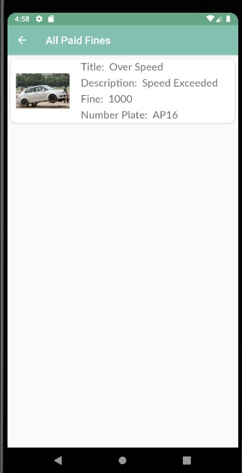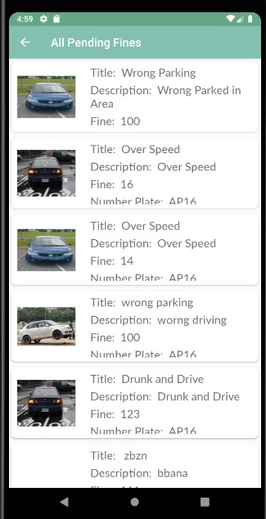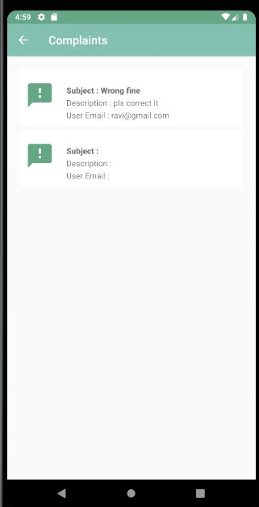

Screen 7: Paid Fines Screen 8: Pending Fines Screen 9: User Complaints

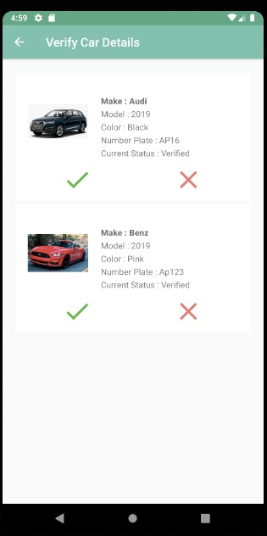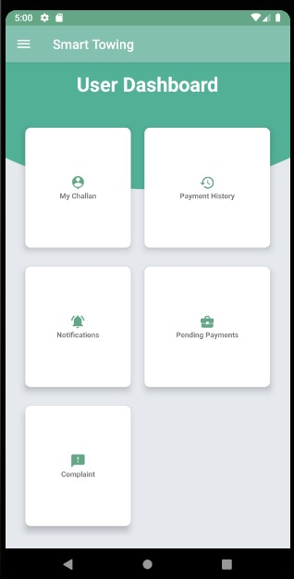

Screen 10: Verify Car Details Screen 11: User Dashboard

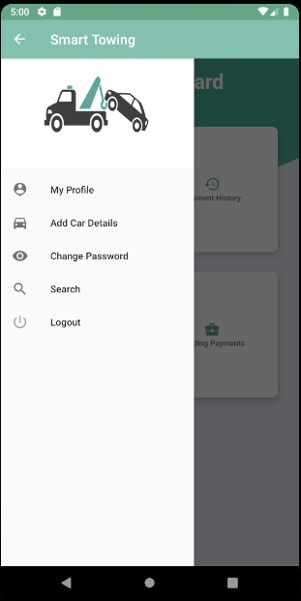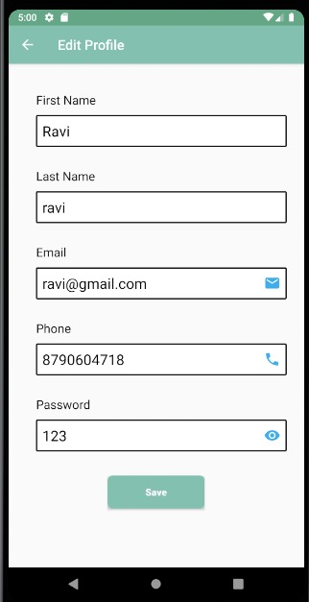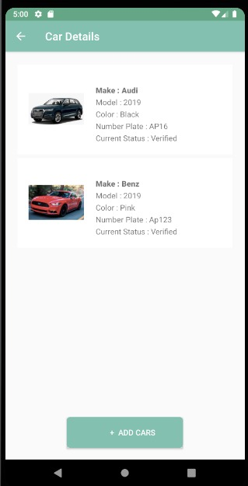

Screen 12: User Menu Screen 13: Edit User Profile Screen 14: User Car Details

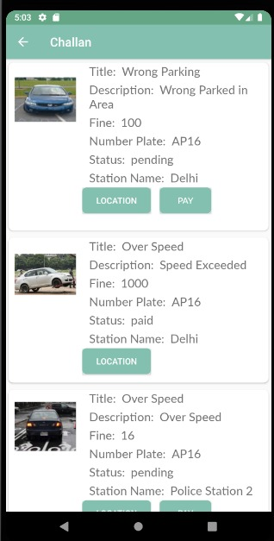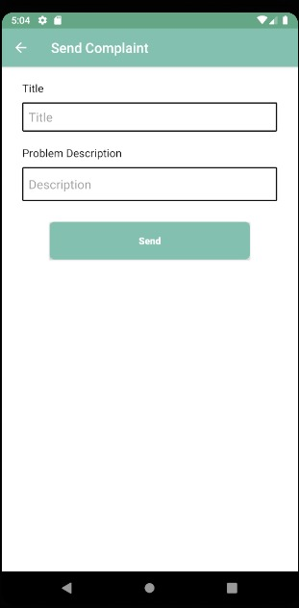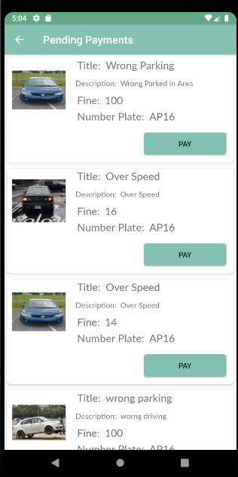

Screen 15: User Challans Screen 16: User Complaints Screen 17: User’s Pending Payments

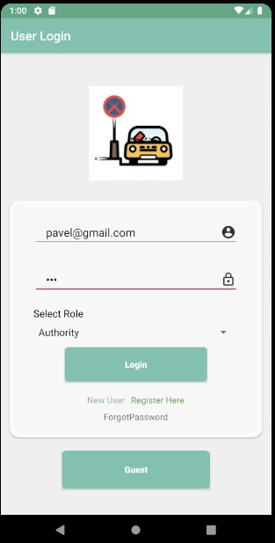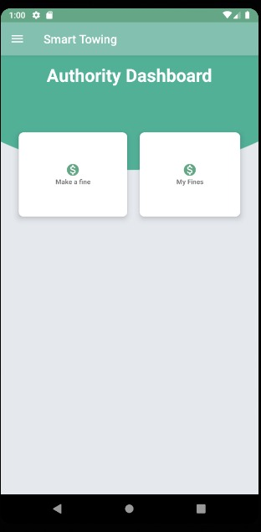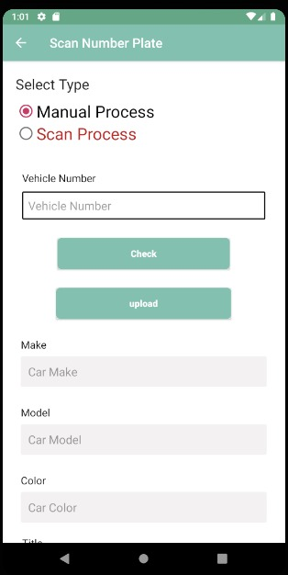

Screen 18: Authority Login Screen 19: Authority Dashboard Screen 20: Scan Number Plate

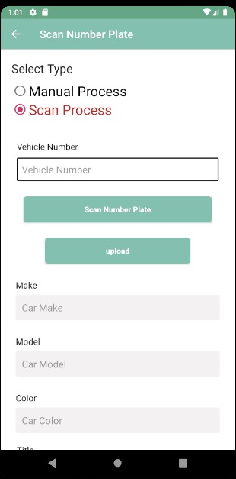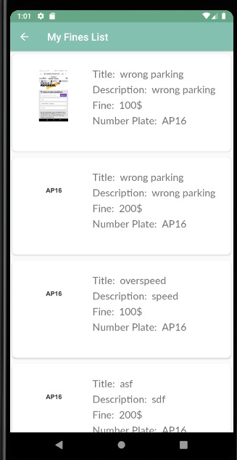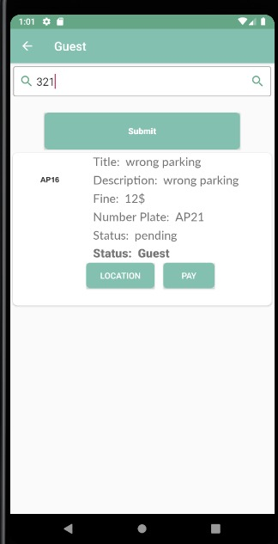

Screen 21,22,23: Scan Number Plate type-2, Authority Fines list and Number Plate Search

**Development Code**

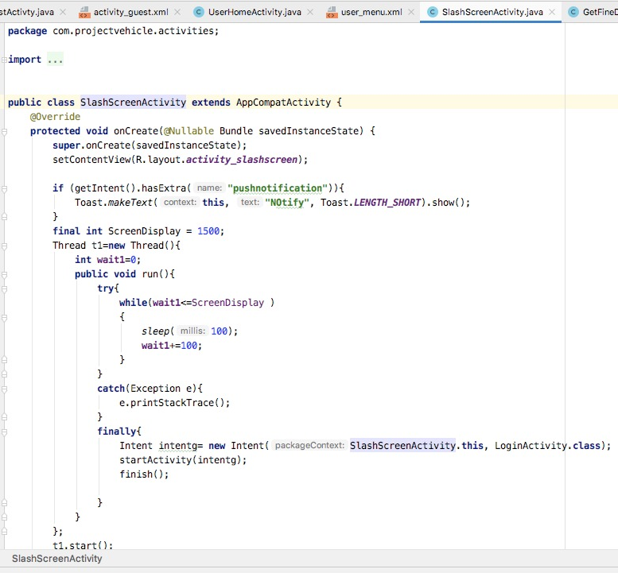

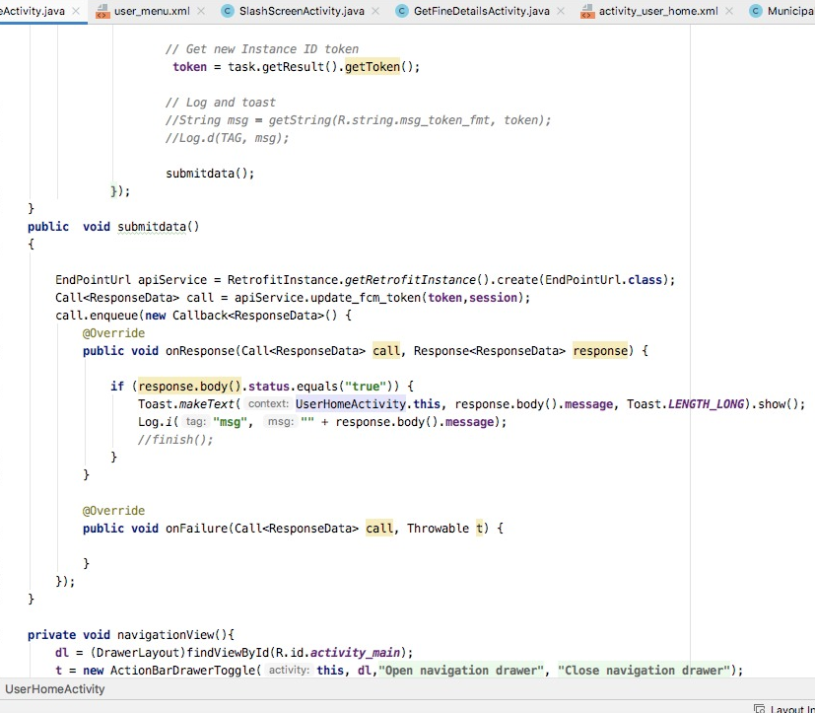

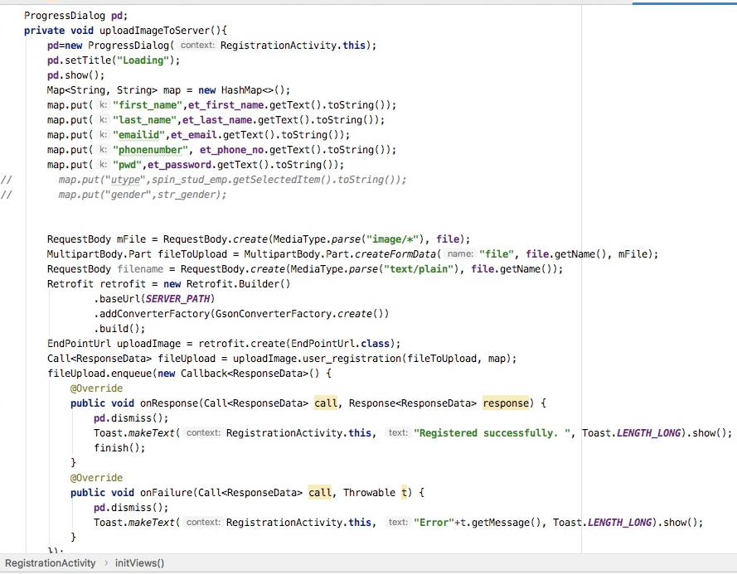

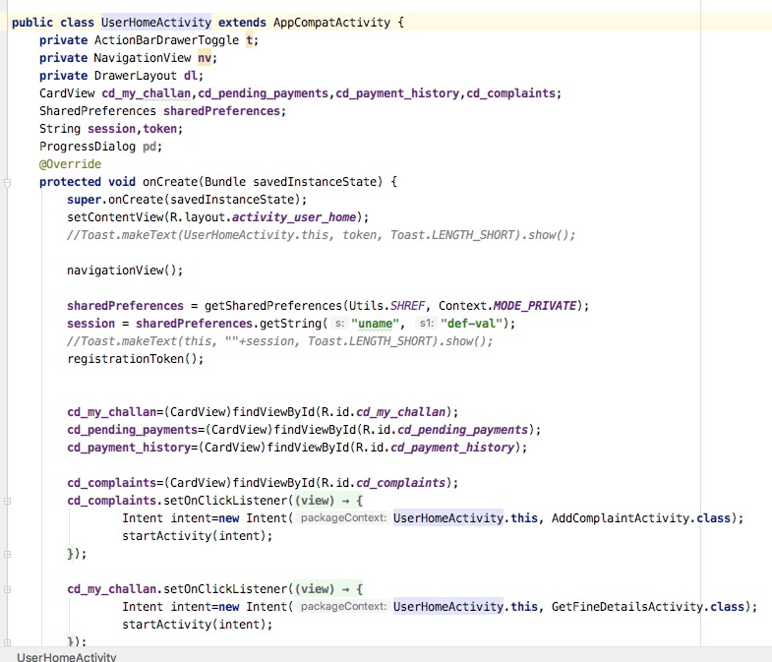

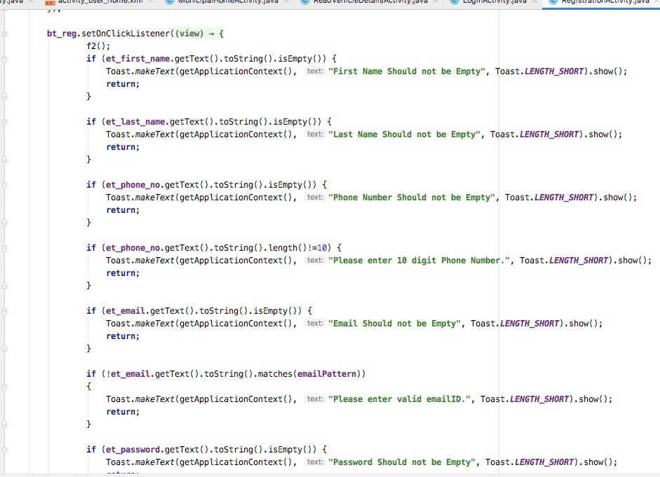

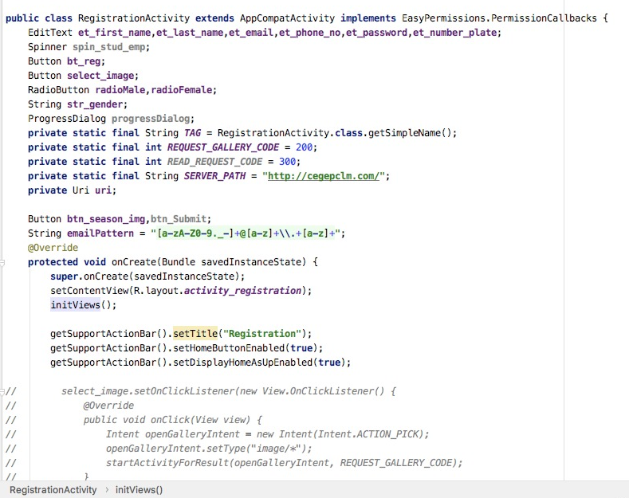

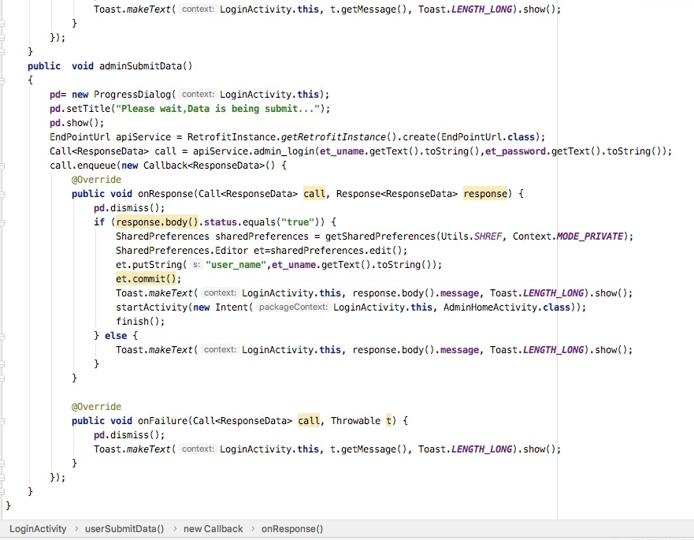

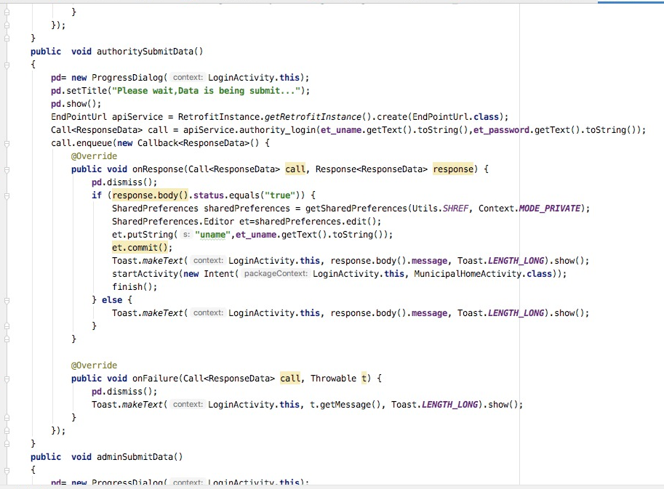

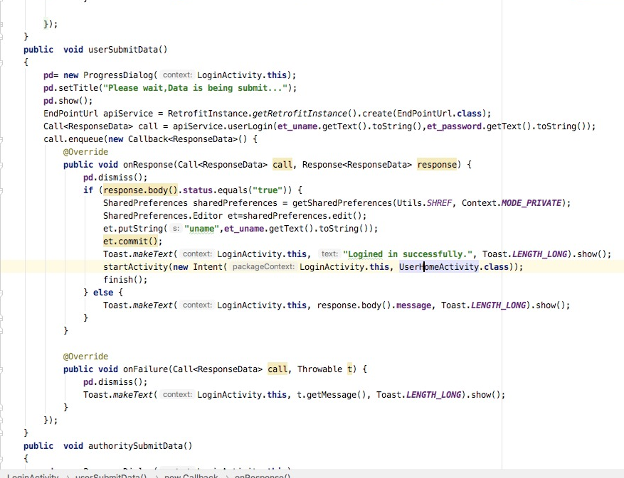

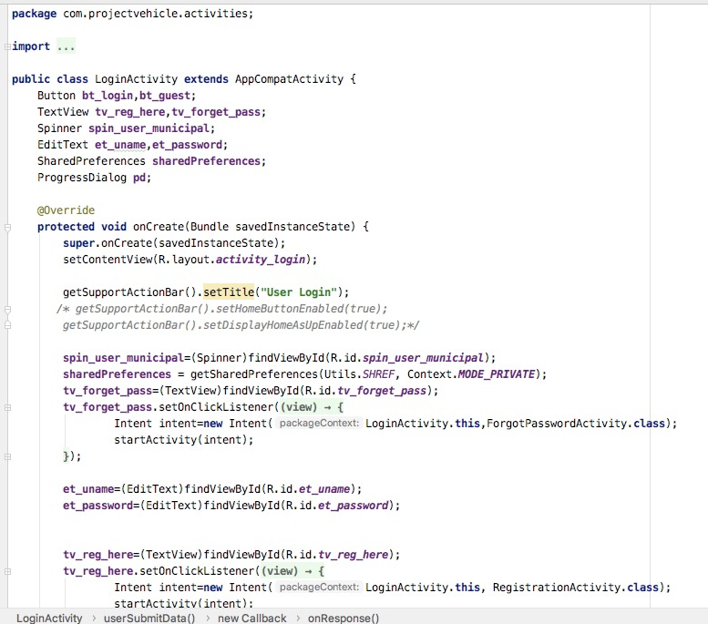

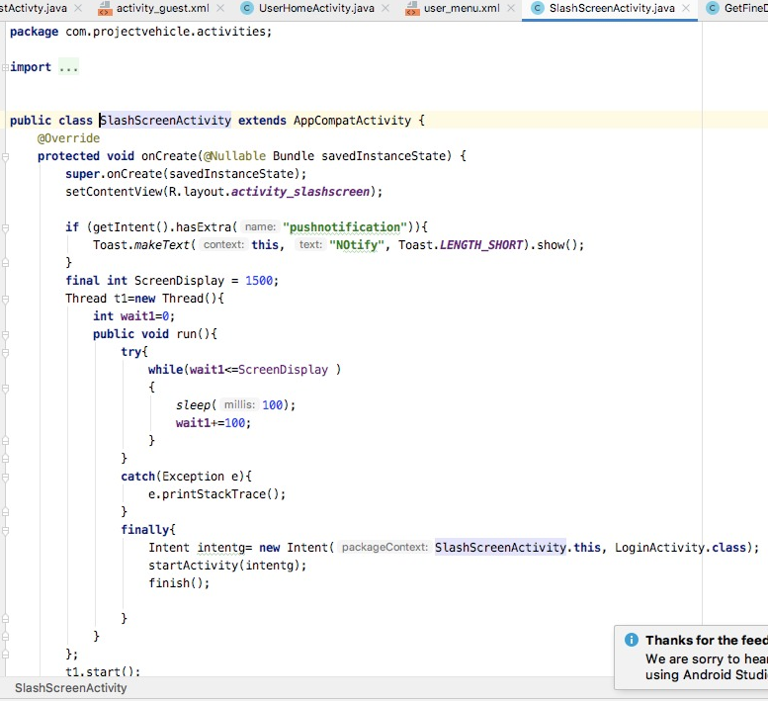

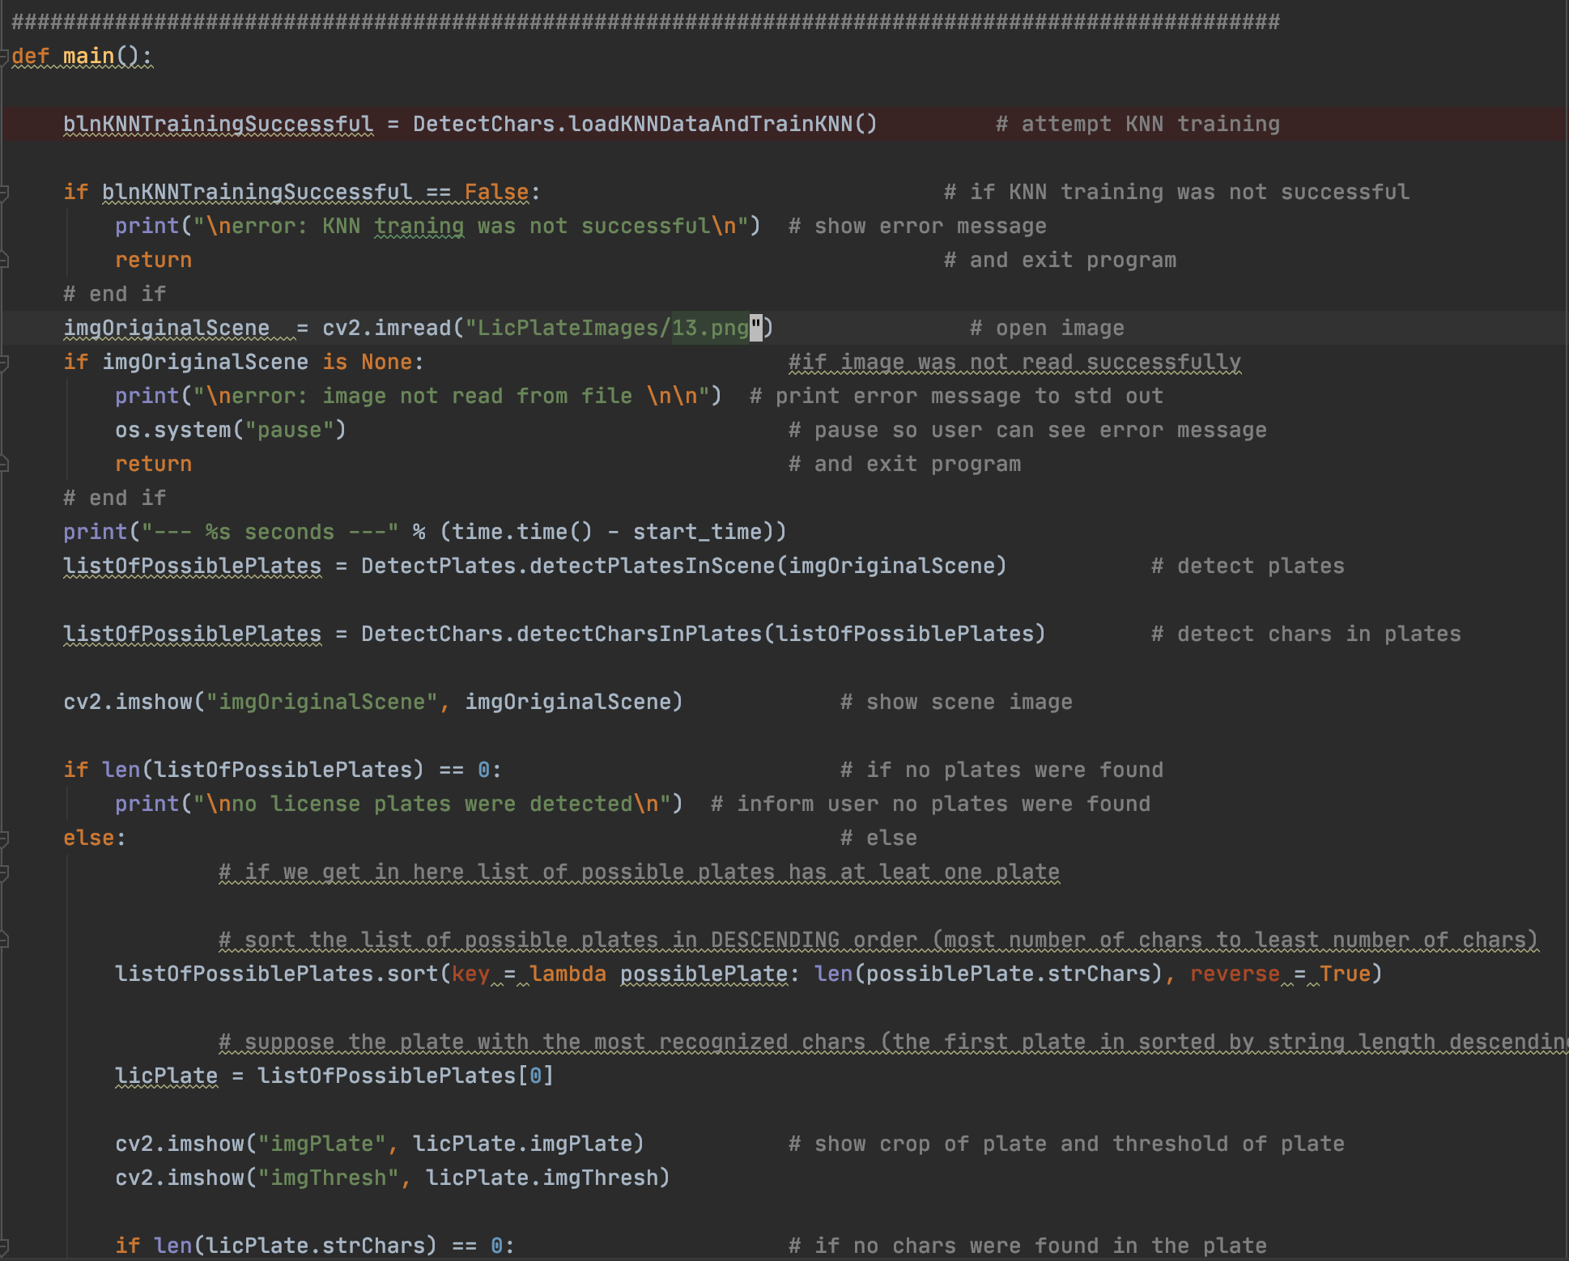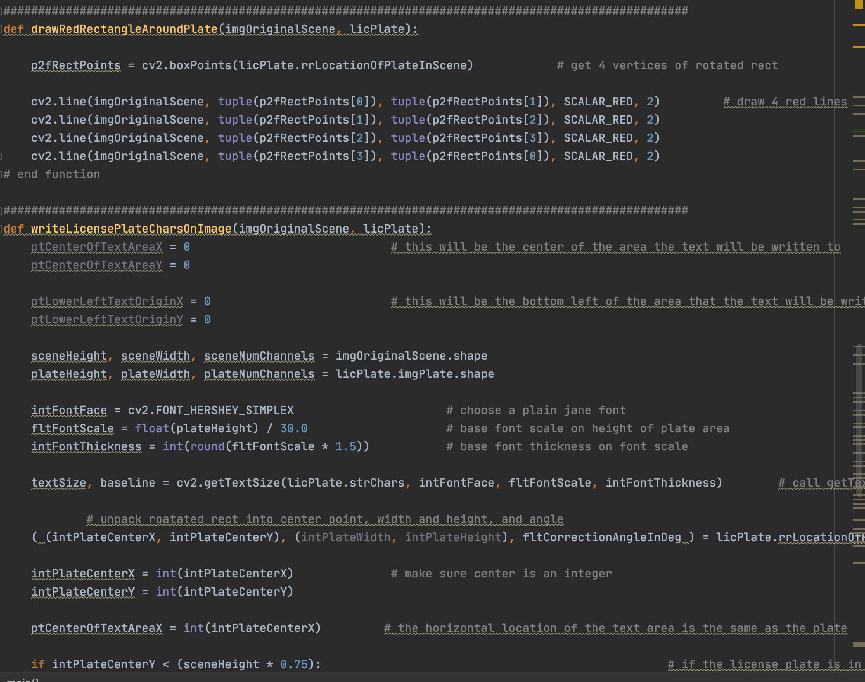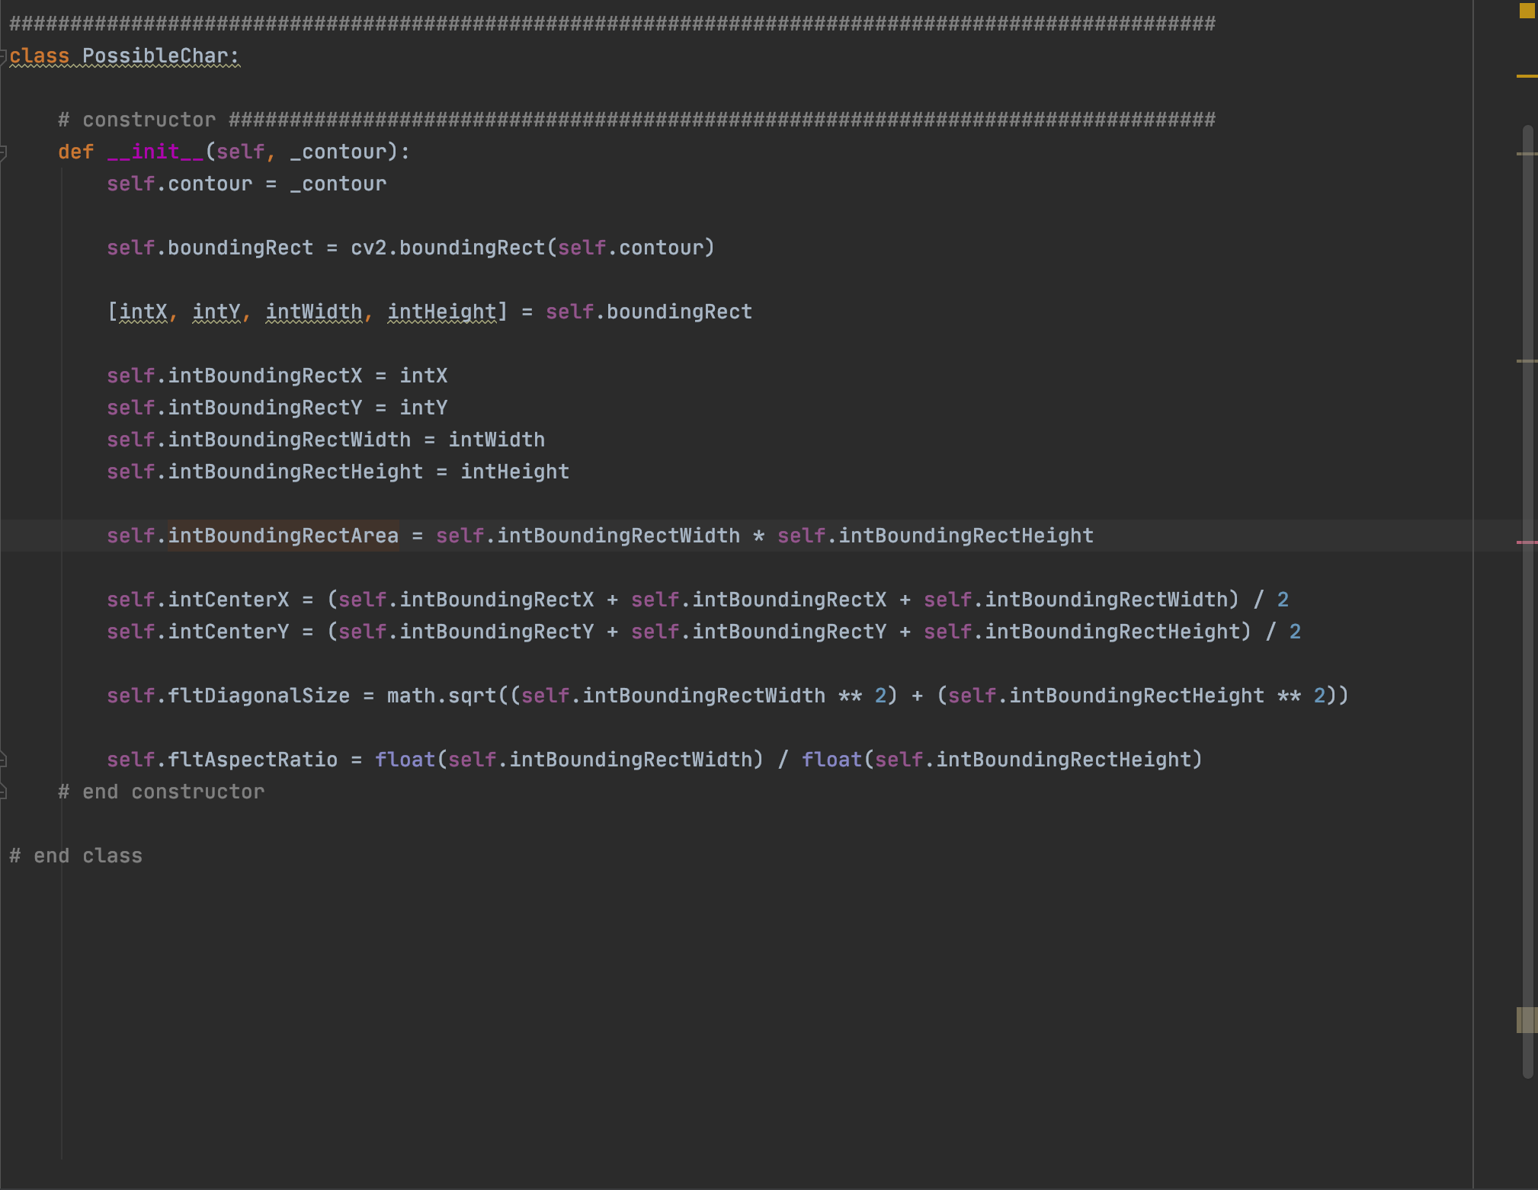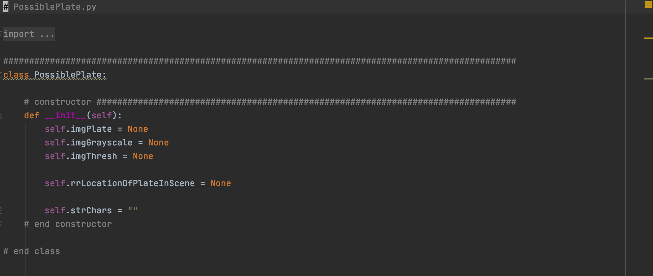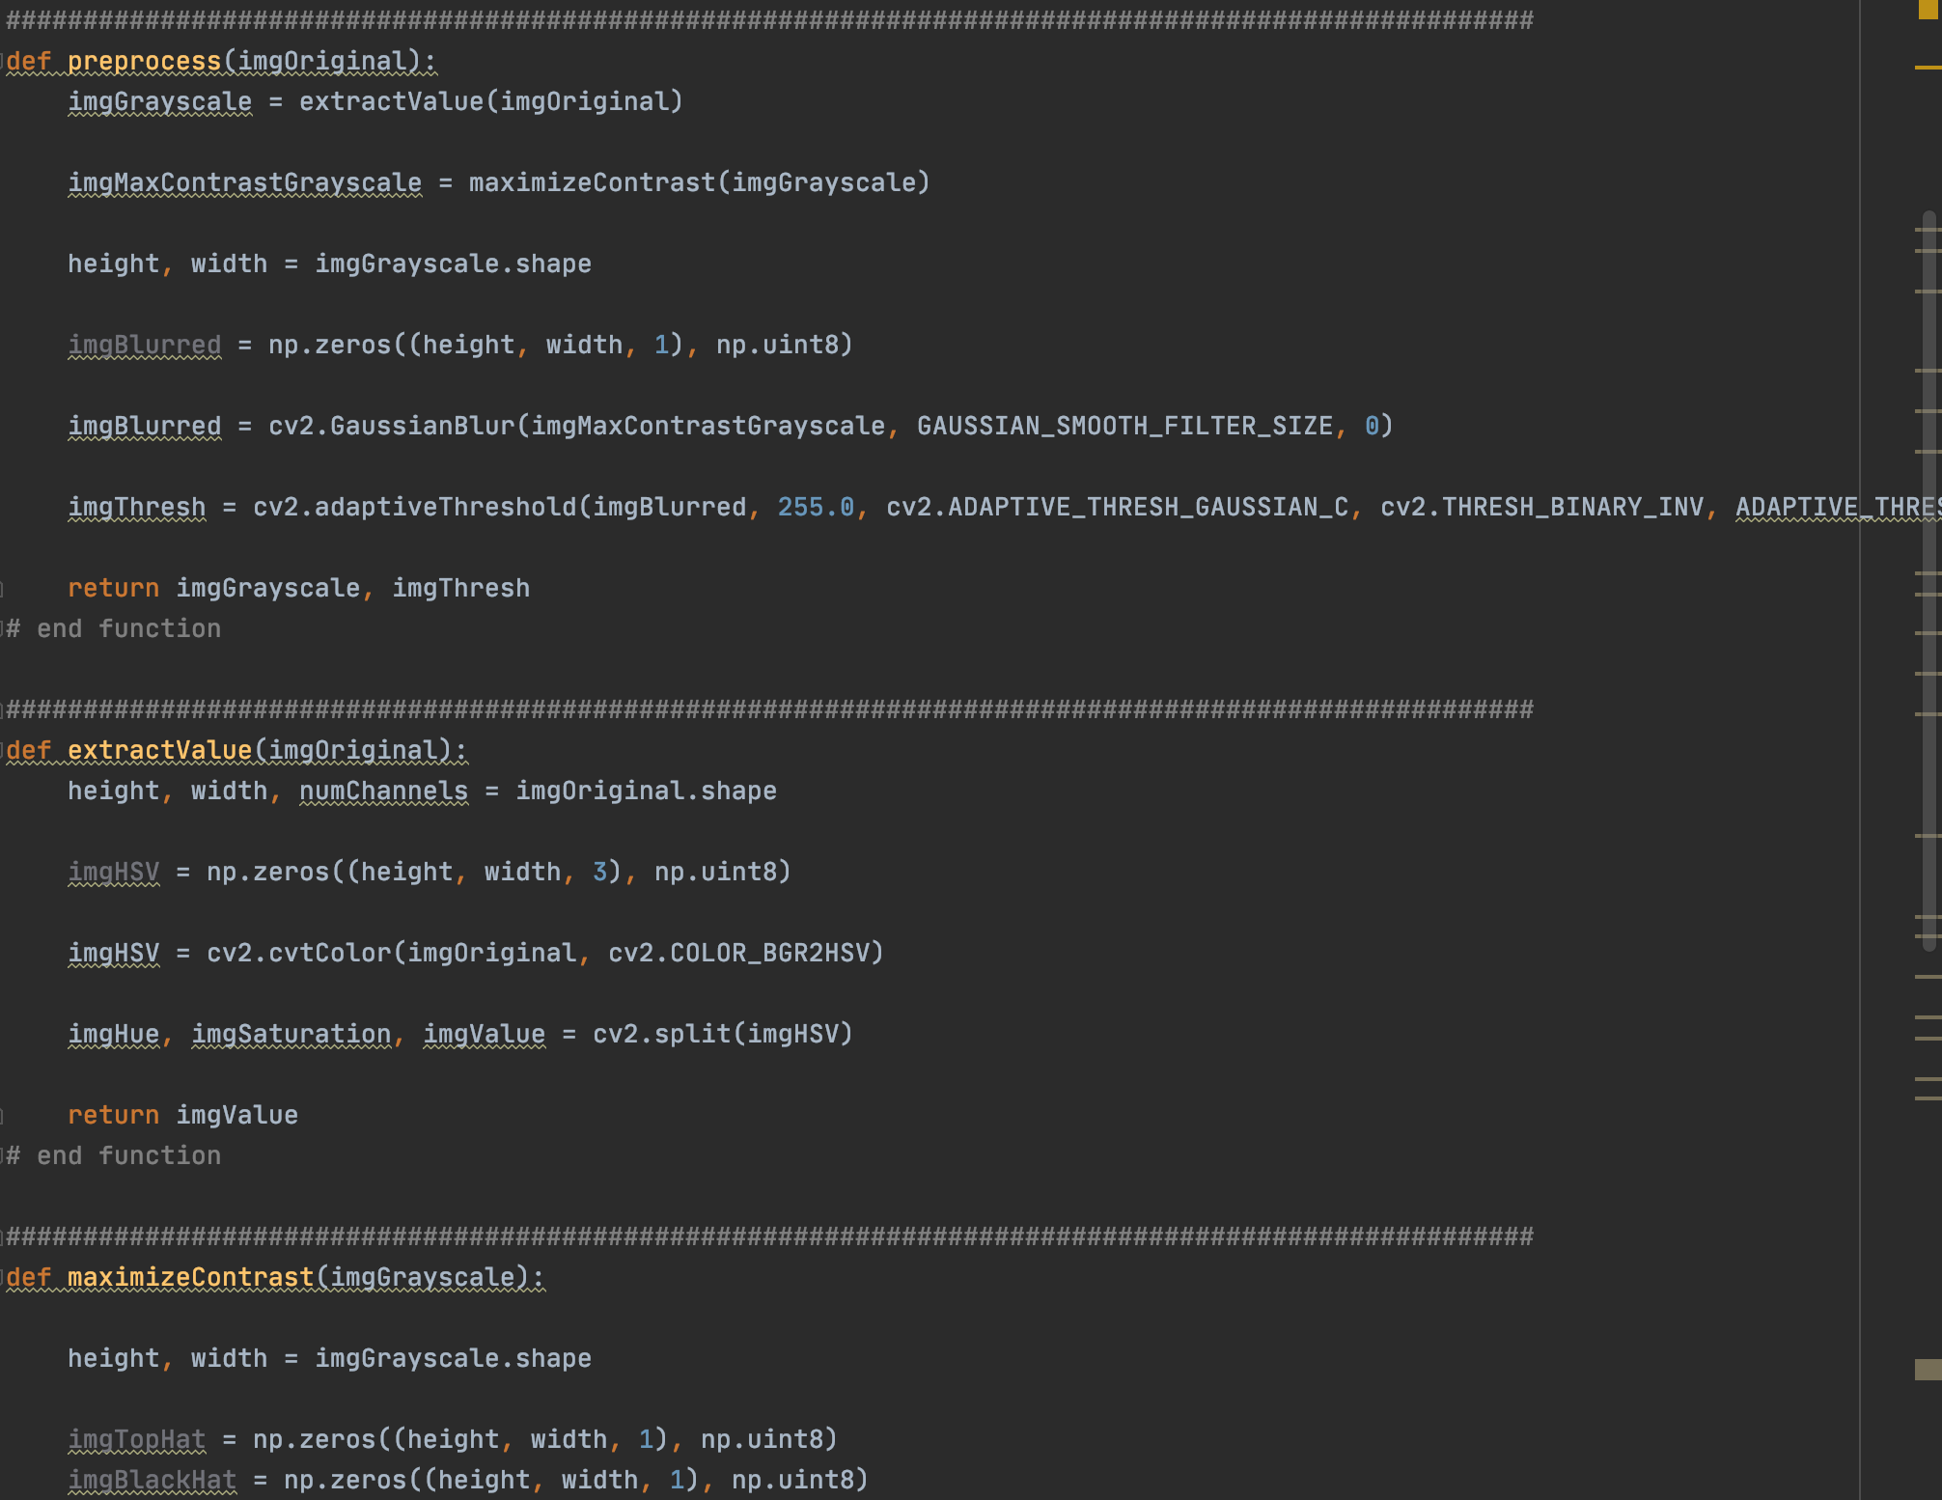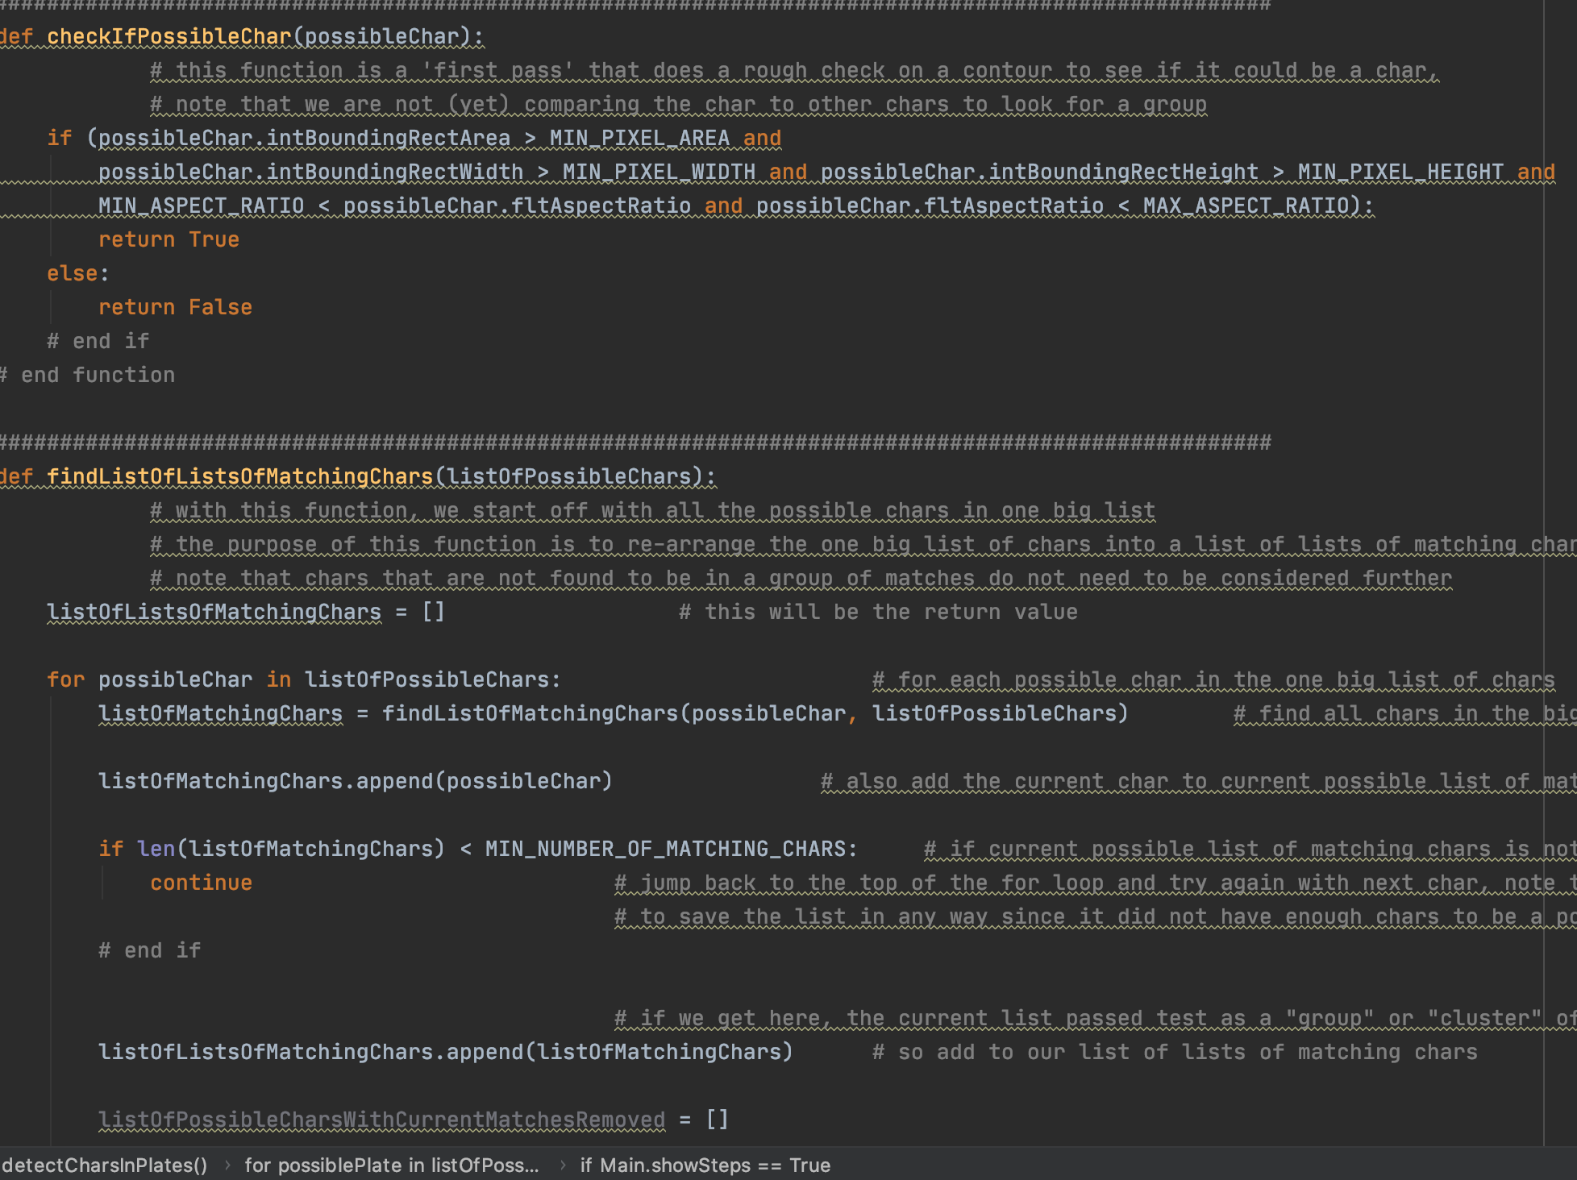

**Web API Calls**

**Web call 1: Authority Registration**

|  |  |
| --- | --- |
| URL   Method | <https://cegepclm.com/SmartTowingSystem/add_user_fine_details.php>   POST |
| Call | Authority Registration |
| Parameters | name = John  phno = 5145492323  emailid = joh@gmail.com  username = john  pwd =john321 |
| Response | Case1  {“Status”:” True”,  “Message”: "{"message”: “Authority is added successfully"}.”}  Case2  {“Status”: “False”,  “Message”: “This email is already taken, please use a different email.”} |
| Keys | |  |  |  | | --- | --- | --- | | “Status” | Status of the response  Possible values: “OK”, “WRONG”,“ERROR” | Mandatory | | “Message” | information for the user | Mandatory | | “Phone” | The phone of the user | Mandatory | | “Password” | The password of the user | Mandatory | |

**Web call 2: Authority Login**

|  |  |
| --- | --- |
| URL   Method | <https://cegepclm.com/SmartTowingSystem/authority_login.php>   POST |
| Call | Authority Login |
| Parameters | username = john  pwd =john321 |
| Response | Case1  {“Status”:” True”,  “Message”: "{"message”: “Logged in successfully "}.”}  Case2  {“Status”: “False”,  “Message”: “Invalid username / password.”} |
| Keys | |  |  |  | | --- | --- | --- | | “Status” | Status of the response  Possible values: “OK”, “WRONG”,“ERROR” | Mandatory | | “Message” | information for the user | Mandatory | | “Phone” | The phone of the user | Mandatory | | “Password” | The password of the user | Mandatory | |

**Web call 3: Authority Manage Profile**

|  |  |
| --- | --- |
| URL   Method | <https://cegepclm.com/SmartTowingSystem/updateauthoritydetails.php>   GET |
| Call | Authority Manage Profiles |
| Parameters | name = John  phno = 5145492323  emailid = joh@gmail.com  username = john  pwd =john321 |
| Response | Case1  {“Status”:” True”,  “Message”: "{"message”: “Details updated successfully"}.”  }  Case2  {  “Status”: “False”,  “Message”: “error updating details.”  } |
| Keys | |  |  |  | | --- | --- | --- | | “Status” | Status of the response  Possible values: “OK”, “WRONG”,“ERROR” | Mandatory | | “Message” | information for the user | Mandatory | | “Phone” | The phone of the user | Mandatory | | “Password” | The password of the user | Mandatory | |

**Web call 4: Filing Complaint**

|  |  |
| --- | --- |
| URL   Method | <https://cegepclm.com/SmartTowingSystem/addcomplaint.php>   GET |
| Call | Filing Complaint |
| Parameters | username = john  pwd =john321 |
| Response | Case1  {“Status”:” True”,  “Message”: "{"message”: “Complaint send successfully"}.”}  Case2  {“Status”: “False”,  “Message”: “error filing complaint.”} |
| Keys | |  |  |  | | --- | --- | --- | | “Status” | Status of the response  Possible values: “OK”, “WRONG”,“ERROR” | Mandatory | | “Message” | information for the user | Mandatory | | “Phone” | The phone of the user | Mandatory | | “Password” | The password of the user | Mandatory | |

**Web call 5: User’s paid fines**

|  |  |
| --- | --- |
| URL   Method | <https://cegepclm.com/SmartTowingSystem/getAllPaidFines.php>   GET |
| Call | User’s Paid Fines |
| Parameters | username = john  pwd =john321 |
| Response | Case1  [{"id":"23","title":"Over Speed","description":"Speed Exceeded","fee":"1000","number_plate":"AP16",  "pic":"http:\/\/cegepclm.com\/SmartToCase2  }  Case2{“Status”: “False”,  “Message”: “No Internet. Please check your connection and try again.”} |
| Keys | |  |  |  | | --- | --- | --- | | “Status” | Status of the response  Possible values: “OK”, “WRONG”,“ERROR” | Mandatory | | “Message” | information for the user | Mandatory | | “Phone” | The phone of the user | Mandatory | | “Password” | The password of the user | Mandatory | |

**Web call 6: All Pending fines**

|  |  |
| --- | --- |
| URL  Method | <https://cegepclm.com/SmartTowingSystem/getAllPendingFines.php>   GET |
| Call | User’s Pending fines |
| Parameters | username = john  pwd =john321 |
| Response | Case1  {"id":"22","title":"Wrong Parking","description":"Wrong Parked in Area",  "fee":"100","number_plate":"AP16",  "pic":"http:\/\/cegepclm.com\/SmartTowingSystem\/images\/p1.png",  "email":"ravi@gmail.com",  "image":"http:\/\/cegepclm.com\/SmartTowingSystem\/images\/c2.png"  "aname":"ravi@gmail.com"},  {"id":"36","title":"Over Speed","description":"Over Speed","fee":"16",  "number_plate":"AP16",  "pic":"http:\/\/cegepclm.com\/SmartTowingSystem\/images\/p3.png",  "email":"ravi@gmail.com",  "image":"http:\/\/cegepclm.com\/SmartTowingSystem\/images\/c2.png"  "aname":"ravi@gmail.com"},“Status”: “False”,  “Message”: “No Internet. Please check your connection and try again.”  } Case2{  “Status”: “False”,  “Message”: “No Internet. Please check your connection and try again.”  } |
| Keys | |  |  |  | | --- | --- | --- | | “Status” | Status of the responsePossible values: “OK”, “WRONG”,“ERROR” | Mandatory | | “Message” | information for the user | Mandatory | | “Phone” | The phone of the user | Mandatory | | “Password” | The password of the user | Mandatory | |

**Web call 7: Add Car Details**

|  |  |
| --- | --- |
| URL   Method | <https://cegepclm.com/SmartTowingSystem/addcar.php>   POST |
| Call | Add Car Details |
| Parameters | username = john  pwd =john321 |
| Response | Case1  {“Status”:” True”,  “Message”: "{"message”: “Car Details Added successfully."}.”}  Case2  {“Status”: “False”,  “Message”: “Car Details already exists.”} |
| Keys | |  |  |  | | --- | --- | --- | | “Status” | Status of the response  Possible values: “OK”, “WRONG”,“ERROR” | Mandatory | | “Message” | information for the user | Mandatory | | “Phone” | The phone of the user | Mandatory | | “Password” | The password of the user | Mandatory | |

**Web call 8: User Fine Detail**

|  |  |
| --- | --- |
| URL   Method | [https://cegepclm.com/SmartTowingSystem/add_user_fine_details.php](https://cegepclm.com/SmartTowingSystem/checkCarDetails.php)  GET |
| Call | User Fine details |
| Parameters | username = john  pwd =john321 |
| Response | Case1  {“Status”:” True”,  “Message”: "{"message”: “Data is added successfully."}.”  }  Case2  {  “Status”: “False”,  “Message”: “error in adding data.”  } |
| Keys | |  |  |  | | --- | --- | --- | | “Status” | Status of the response  Possible values: “OK”, “WRONG”,“ERROR” | Mandatory | | “Message” | information for the user | Mandatory | | “Phone” | The phone of the user | Mandatory | | “Password” | The password of the user | Mandatory | |

**Web call 9: User Pay Fine**

|  |  |
| --- | --- |
| URL   Method | [https://cegepclm.com/SmartTowingSystem/add_user_fine_details.php](https://cegepclm.com/SmartTowingSystem/checkCarDetails.php)  GET |
| Call | User Pay fine |
| Parameters | username = john  pwd =john321 |
| Response | Case1  {“Status”:” True”,  “Message”: "{"message”: “Data is updated successfully."}.”  }  Case2  {  “Status”: “False”,  “Message”: “Transaction error failed to pay fine.”  } |
| Keys | |  |  |  | | --- | --- | --- | | “Status” | Status of the response  Possible values: “OK”, “WRONG”,“ERROR” | Mandatory | | “Message” | information for the user | Mandatory | | “Phone” | The phone of the user | Mandatory | | “Password” | The password of the user | Mandatory | |